Village of Baldwinsville

Climate Action Plan 2020

Collaborators:
Marisa Barber, Angie Alberto Escobar, Benjamin Gould, Bogdan Litvinenko, Emily Purce, James Quinn
SUNY College of Environmental Science and Forestry
May 1, 2020; revised by Amanda Mazzoni, CNY RPDB, May 7, 2020
Contents
Acknowledgments 4
Executive Summary 5
Introduction 5
Why Develop A Climate Action Plan? 6
Goals and Targets 7
Goals 7
Targets 8
Current Initiatives 9
Baseline Assessment 9
Proposed Initiatives 10
Reduction of Stationary Combustions in Offices and Government Buildings 12
Water Infrastructure Electricity Use Abatement 13
Energy Efficiency First 14
WISE Program 15
Water Conservation Campaign 16
Powering Water and/or other Municipal Facilities with Solar Energy 18
Highway Vehicle Fleet Mobile Combustion Emissions and Energy Use Abatement 22
Additional Funding Sources to Consider 24
Paying for Energy Efficiency Audits 24
Paying for Energy Efficiency Improvements 25
Employee and Community Engagement 25
Carpooling and Biking Programs 26
Reducing Waste 27
Energy Conservation 28
Urban Forestry 29
Next Steps 30
Implementation Considerations for Actions Discussed 30
Progress Reports 30
Updating the Climate Action Plan 31
Appendix 32

Acknowledgments
We want to thank:

Amanda Mazzoni of the Central New York Regional Planning and Development Board
Josh Cousins of SUNY College of Environmental Science and Forestry
Gregg Humphry of the Village of Baldwinsville

for assisting us on the development of this Climate Action Plan for the village of Baldwinsville, New York.

Thank you!

If questions arise, please contact:

Marisa Barber - marbarber13@gmail.com
Angie Alberto Escobar - angie.alberto13@gmail.com
Benjamin Gould - bvgould@syr.edu
Bogdan Litvinenko - blitvine@syr.edu
Emily Purce - enpurce@syr.edu
James Quinn - Jamesquinn1234@gmail.com

Executive Summary
Our collective goal is to reduce the greenhouse gas emissions produced by the Village of Baldwinsville from the 2018 baseline, as well as create a situation that makes financial sense in tandem. This is to be done not only to reinforce the environmental and fiscal well-being of Baldwinsville, but also to meet the requirements for the New York State Climate Leadership and Community Protection Act, which calls for a 100% reduction in carbon emissions across all sectors by 2040. Currently, government-based sectors of emissions are the most easily abated, due to the direct influence the Board of Baldwinsville has to enforce energy-centered mandates. Thus, those will be our focus. We will explore solutions relating to the emission sectors of transportation, buildings and facilities, and water and sewers. Of these sectors, we’ve described 6 potential implementation focus areas: emission reductions in office buildings, water infrastructure electricity abatement, reduction of mobile (vehicle) emissions, green purchases, utility conversions to renewable energy, and employee and community engagement. Through these implementations we seek to highlight areas of potential emission abatement, and continue Baldwinsville’s journey as a Climate Smart Community.

Introduction
Global climate change is a long-term trend of weather variations. This can be both natural and human caused. Human caused, or anthropogenic, climate change comes from the greenhouse gases humans emit largely through the burning of fossil fuels for electricity, heat, and transportation, but also from deforestation, livestock farming, etc. The amount of carbon dioxide in Earth’s atmosphere has risen by 40% since the beginning of the industrial revolution. These greenhouse gases cause the greenhouse effect which is when Earth’s forests and oceans aren’t able to keep up with absorbing as much greenhouse gases as humans are emitting, so carbon dioxide remains in the atmosphere and causes an increase in temperature. Some effects of global anthropogenic climate change on top of warmer temperatures are extreme weather, contaminated air, health issues, rising waters, warmer and more acidic oceans, and endangered or destroyed ecosystems (Denchak, 2017).
In New York state climate change is causing increased precipitation, specifically in the winter, with larger precipitation events, sea level rise, earlier spring, and relocation of breeding populations. In the future New York state can expect warmer temperatures, extreme summers, even more precipitation, sea level rise, and a multitude of health risks like asthma and allergies (Impacts of Climate Change in New York, n.d.). Local climate change mitigation is important in the fight against global anthropogenic climate change because it creates a healthy local environment that federal policy doesn’t always ensure. Effects of climate change that are better handled through local mitigation measures include air and water, floods, extreme weather risks like drought and wildfires, and pollution (Kelly et al., 2017).

Why Develop A Climate Action Plan?
The village of Baldwinsville, New York has a population of 7,550 people within 3.1 square miles as of 2018. In 2010 Baldwinsville’s emissions measured 597 MTCO2e. At the time it was projected that Baldwinsville would increase their emissions 6.9% by 2025. Baldwinsville adopted the New York State Climate Smart Community (CSC) pledge in 2015. The next step is for the Village to consider Climate Smart Communities Certification, a certification that can be earned by working through the NYS Department of Environmental Conservation’s (DEC) program, earning points for various climate smart activities. CSCs can also receive grants and assistance. The CSC certification program sets a framework for climate action and recognizes communities for their leadership. We will be using their framework as a guide to our Climate Action Plan (Actions, n.d.). CSC Certification is also one of ten high impact actions through New York State Energy Research and Development Authority’s (NYSERDA) Clean Energy Community (CEC) program. Communities that compete four of the ten high impact actions can receive grants for clean energy projects. The Village of Baldwinsville became a designated CEC in August of 2018 and claimed a $5,000 grant for doing so.
In 2019 a group of SUNY College of Environmental and Science students compiled a local government operations greenhouse gas inventory update report for Baldwinsville. In their report, the students compared the 2010 inventory numbers with 2018 data. In 2010 Baldwinsville released 597 MTCO2e, while in 2018 they only released 523.83 MTCO2e. The 2018 data was analyzed under scopes 1 and 2 in fifteen departments. Scope 1 emissions are direct emissions from owned or controlled sources within the jurisdictional boundary and they totaled 75% of 2018 emissions in Baldwinsville. Scope 2 emissions are indirect emissions from the generation of purchased electricity which totaled 25% of emissions in Baldwinsville. The largest single source of emissions came from government/office buildings at 24%, followed by vehicle highway fleet at 22%, and water infrastructure at 19% (Bogan et al, 2019.). Graphs from 2018 data can be seen in Figure 1 and Figure 2 in the Appendix.

Goals and Targets

Goals
Purchase green electricity: A large percentage of greenhouse gas emissions comes from the burning of fossil fuels to produce electricity
Invest in renewable energy installation: Data has shown pursuing community solar infrastructure and/or Community Choice Aggregation (CCA) programs have been worthwhile
Participate in urban forestry: The care and management of trees and plant life within urban settings for the overall improvement of the area could help reduce/offset municipal operations emissions by reducing the amount of atmospheric C02 through sequestration
Apply for Climate Smart Community Grants: The Climate Smart Community (CSC) is a New York State program designed to help local governments reduce greenhouse gas emissions and adapt to a changing climate. The grant program has been issued yearly since 2016 via the New York State Consolidated Funding Application (CFA).
- Currently 298 communities are registered as being Climate Smart
- Approximately 8.5 million New Yorkers are living in Climate Smart Communities
- Communities within the Climate Smart registry have received state grants as well as rebates in order to continue the promotion and use of renewable energy, zero emission vehicles, and eco-friendly infrastructure. Grants are typically given for implementation projects of climate-smart technologies and infrastructure

Targets
Reduce MTC02e by approx. 30% Over the Next 5 Years: MTC02e is an abbreviation for metric tonnes of C02 emissions, one of the most common greenhouse gases. The 30% level was chosen as a starting point, as it falls in line with both the CSC guidelines, as well as the United Nations sustainability goals. The U.N. sustainability goals provide a reasonable target for the community in terms of sustainability and development.

Current Initiatives
As of 2020 Baldwinsville has changed all streetlights to LED, which has saved a considerable amount of energy. Baldwinsville is currently working on changing other indoor/outdoor light bulbs to LED bulbs as they need to be replaced. The village has insulated the Senior Center and Water Department, and are planning to insulate the Village Hall roof deck. Insulating a space keeps the heat or cool air in, so less gas or electricity is used to keep the temperature stable. The village uses variable speed drives with their water pumps which decreases water usage. Baldwinsville has also been identifying and fixing leaks in their water system, which has also decreased their water usage. Baldwinsville has many parks within the village, and is also a TreeCityUSA. Trees within the village contribute to carbon sequestration.

Baseline Assessment
A local government operations greenhouse gas inventory update for the village of Baldwinsville was compiled in 2019 using 2018 data. Emissions data was reported by stationary combustions emissions, electricity emissions, and mobile emissions. The inventory report further breaks down emissions by department or sector. The departments with the highest emissions and/or energy use will be assessed for mitigation in this local government climate action plan.
The inventory for stationary combustions included offices and government buildings, water infrastructure, community buildings, public utilities, and outdoor lighting. Shown in Figure 3 (see Appendix), offices and government buildings in the Village of Baldwinsville were the greatest contributors to stationary combustion emissions with 98 metric tons of CO2E annually. This includes 1840 mmBTU of energy use and 1790 mcf of natural gas use annually, shown in Figure 4.
Figure 5 & 6 show the electricity audits conducted on offices and government buildings, water infrastructure, community buildings, public utilities, outdoor lighting, schools, and health firms. Electricity consumption is driven by the water infrastructure of Baldwinsville at 496,610 kWh annually with emissions of 66.69 metric tons of CO2E.
Lastly, an audit for mobile combustion emissions was conducted on the police fleet, sewer vehicle fleet, water vehicle fleet and highway vehicle fleet. Mobile combustion emissions are led by the highway vehicle fleet of the village with emissions estimated at 114 MT CO2e. Additionally, the energy used by the highway vehicle fleet is 1178 mmBtu of diesel and 388 mmBtu of gasoline per year.

Proposed Initiatives
Below are multiple actions that the village of Baldwinsville can consider to promote sustainability. The following options are rated 1 to 5, with 5 being the highest priority actions for the Village.

Priority Ratings:
Recommendation | Rating | Comment
Reduce Energy Consumption with ENERGY STAR Appliances | 4 | Depending on the current incentives and cost, we recommend installing ENERGY STAR Appliances
Water Infrastructure - Energy Efficiency First | 5
Water Infrastructure - Water Conservation Campaign | 5
Converting to Green Energy - Powering water infrastructure and other municipal facilities with Solar Energy | 4 | There are various options for powering municipal facilities with solar energy that could also reduce costs to the Village.
Water Infrastructure - WISE Program | 5
Highway Vehicle Fleet Mobile Combustion Emissions and Energy Use Abatement | 4 | The Village can conside rless idle time (LIT) battery arrays for police cruisers. We also recommend that the Village of Baldwinsville consider biodiesel and/or electrification of the vehicle fleet. There are a number of state incentive/grant programs that can help defray the costs of electric vehicles, both for light and heavy duty vehicles.
Green Purchasing policy | 3 | The Village can consider adopting a policy for equipment, appliances, and/or vehicle fleet to purchase a more efficient version than was previously required
Employee and Community Engagement - Carpooling and Biking Programs | 3
Employee and Community Engagement - Reducing Waste | 4
Employee and Community Engagement - Energy Conservation | 4
Employee and Community Engagement - Urban Forestry | 5 | As a group, we would like to advise that in our best opinion, not to plant any more Ash Trees. Planting more will only increase the food supply of Emerald Ash Borer. We do recommend that a diluted insecticide be drenched into the soil around a tree. The tree will then absorb the insecticide through its roots and lacing its trunk with insecticide, effective eliminating the Emerald Ash Borer.

Reduction of Stationary Combustions in Offices and Government Buildings
Stationary combustion emission sources include emissions created by on-site combustion of fuel, like a natural gas hot water heater for an office building or an oil-burning boiler (EPA.gov).
According to the U.S. Department of energy, 20% of all the energy we use in the United States goes to powering commercial and nonresidential buildings. In order to effectively reduce the amount of GHG we emit into the atmosphere every year, minimizing the carbon footprint of these buildings must be a priority.
Changing consumer habits is one of the easiest steps you can take in order to directly impact GHG emissions. Energy STAR recommends implementing appliance and technical equipment that is the latest technology in saving energy. Companies like iGo Green have developed surge protectors that kill phantom power loss (iGo). The surge protector automatically powers down outlets when not in use and powers up again when devices need power - reducing standby power by up to 85% (iGo). The Village of Baldwinsville could consider purchasing similar “smart” surge protectors to help reduce phantom power loads of appliances in municipal buildings when they are not in use.
The Village could also implement a green purchasing policy for purchasing future office equipment and electronics, such as purchasing equipment that has an EnergyStar certified approval.
If the Village cannot afford or doesn’t need to buy new equipment yet, there may be “sleep settings” on equipment that could be implemented to help reduce energy use of equipment while not in use.
ENERGY STAR has also developed a tool called ENERGY STAR Portfolio Manager which helps track building energy use. The Village of Baldwinsville has adopted NYSERDA’s Benchmarking resolution as part of the CEC program, which requires the Village to upload building energy use data to Portfolio Manager and post use and emissions data to the Village website every year. National Grid has recently set up a data upload process that will provide customers with quarterly building usage information automatically, which the Village should consider opting into to make this process quicker and easier moving forward. Portfolio Manager is a great tool to better understand energy consumption in a more in-depth way so then clients can start to craft an Action Plan for reducing energy use in buildings.

Water Infrastructure Electricity Use Abatement
Water and wastewater utilities are typically the largest consumers of energy in municipalities, often accounting for 30 to 40 percent of total energy consumed. In Baldwinsville 50 percent of the electricity consumed is through the water infrastructure. As of 2018 the village of Baldwinsville’s average yearly emissions from the water infrastructure sector is 66.69 metric tons of Carbon dioxide equivalent and uses 496,610 kWh of electricity. Implementing energy efficiency measures at water sector systems will reduce electricity consumption, significantly decrease operating costs and abate GHG emissions.

Energy Efficiency First
The village of Baldwinsville should consider employing energy audits at their water systems to identify additional areas for energy cost savings. A key task for any municipality to take advantage of this and other similar programs is to appoint a person or a board to seek out and identify the options and potential benefits, and apply actions that make the most sense.
Walk-through (also called ASHRAE Level 1) audits could provide a “first cut” assessment of energy savings; they’re especially valuable to small utilities with simple production and distribution systems, and facilities that have never received an energy audit. While walk-through audits lack a detailed analysis of potential energy efficiency measures (and only sometimes include rough pay-back period estimates), they reliably include relatively simple and immediately affordable recommendations—such as changes in operation timing (based on utility rate schedules), and upgrades to lighting, heating, ventilating and air conditioning (HVAC), and pumping equipment. Through the CEC program, NYSERDA plans to offer this kind of walk-through audit in the near future.
Detailed process audits (also called Level 2—or, if more refined—Level 3 ASHRAE audits) require a more in-depth conversation between the facility and professional auditors experienced in water and wastewater systems. Detailed process audits are the most cost-effective for mid-size and large facilities that lack in-house time to investigate energy efficiency opportunities, and that have not recently received an energy audit. Detailed process audits often involve equipment field tests, inventorying equipment energy performance data, creating energy profiles for equipment and systems, discussing potential O&M changes, and evaluating potential energy efficiency and renewable energy projects. Detailed process audits provide comprehensive information on the pay-back periods associated with the recommended measures. However, Level 2 or Level 3 audits can often be cost-prohibitive, especially for smaller municipalities or buildings.

WISE Program
Maximizing the efficiency of water distribution systems is incredibly complex and difficult to accomplish. Water agencies alone may not have the experience or knowledge to minimize the energy consumption of their water infrastructure. The Water Infrastructure and System Efficiency (WISE) program by Lincus is designed to specifically assist municipalities' water and wastewater sectors in identifying energy efficiency projects and securing incentives to offset installation costs and engineering services. Lincus uses a holistic approach, combining existing pump tests and hydraulic modeling to evaluate how water and wastewater customers can optimize their distribution and treatment systems. The program focuses on both individual pump efficiency improvements as well as comprehensive system optimization measures. This comprehensive solution offers no-cost energy engineering services, project support, and cash incentives. The program focuses on both individual pump efficiency improvements and comprehensive system optimization measures. These measures include, but are not limited to the following:
For Water Systems: Pump overhaul, pump sequencing, variable frequency drives, storage system, pump station improvements, and overall distribution system optimization.
For Wastewater Systems: Aeration blower improvements, and VFDs, DO control, VFDs on pumps, pump efficiency improvements, optimization of aerobic digestion, optimization of bio-solids mixing, installation of high efficiency diffusers, blower efficiency improvements, indirect evaporative cooler­ single stage, centrifuge operation optimizations.
Lincus’ proven energy-efficiency strategies bridge the gap between project identification and implementation by providing pump test information in ranked order of opportunity using their integrated Pump tool (iPT). The Village could consider this or another similar program that focuses on audits for water systems, since water infrastructure is the largest consumer of electricity for the Village and has not been audited for efficiency and improvements recently.
Some strategies to consider to help reduce energy use from water infrastructure include:
- Identifying capital improvements (motors, blowers, variable frequency drives, etc) and operational improvements
- Operational improvements can result in substantial savings with little to no cost
– Time of operation, load demand contracts, unnecessary equipment, energy management systems, etc.
- Audits can be conducted on plant designs – very cost effective

Water Conservation Campaign
The simplest mitigation of electricity use and GHG emissions from the water infrastructure of the village of Baldwinsville can be addressed by reducing the amount of water that is consumed in the village. Water conservation can reduce the emissions and electricity use of water infrastructure and is low-cost and effective.
There are many environmental and fiscal reasons to conserve water. The Annual Drinking Water Quality Report for 2018 states motives for water conservation:
- Saving water saves energy and some of the costs associated with both of these necessities of life
- Saving water reduces the cost of energy required to pump water and the need to construct costly new wells, pumping systems and water towers
- Saving water lessens the strain on the water system during a dry spell or drought, helping to avoid severe water use restrictions so that essential firefighting needs are met
Implementing Water Conservation Campaign
There are many ways to decrease household water and energy use through simple daily tasks or the installation of water- and energy-efficient products. EPA estimates that retrofitting one out of every 100 American homes with water-efficient fixtures would save about 100 million kilowatt-hours of electricity per year and avoid adding 80,000 tons of greenhouse gas into the atmosphere. The Village can play a role in helping residents to conserve water by implementing a water conservation campaign. The campaign can focus on becoming conscious of the amount of water each household is using, and by looking for ways to use less whenever possible.
Conservation tips that can be incorporated into a conservation campaign:
- WaterSense - Through the WaterSense program, the EPA offers a label for products and services that are certified to save water without sacrificing performance. Manufacturers, retailers, builders, utilities, and others can partner with the program to help raise awareness of WaterSense labeled products and an ethic of careful water use.
- Alliance for Water Efficiency - The Alliance for Water Efficiency is a national organization that serves as a clearinghouse and advocate for water efficiency research, evaluation, and education.
- Energy STAR programs incentivize consumers to purchase energy-efficient appliances with rebates
- Automatic dishwashers use 15 gallons for every cycle, regardless of how many dishes are loaded. So get a run for your money and load it to capacity.
- Turn off the tap when brushing your teeth.
- Check every faucet in your home for leaks. Just a slow drip can waste 15 to 20 gallons a day. You can save almost 6,000 gallons per year by fixing it.
- Check your toilets for leaks by putting a few drops of food coloring in the tank, watch for a few minutes to see if the color shows up in the bowl. It is not
uncommon to lose up to 100 gallons a day from one of these otherwise invisible toilet leaks. You save more than 30,000 gallons a year by fixing it.
- Use your water meter to detect hidden leaks. Simply turn off all taps and water using appliances. Then check the meter after 15 minutes. If it moved, you
have a leak.
- Take showers instead of baths. The usual bath requires 36 gallons, the usual shower 25 gallons; 20 gallons is enough for a bath, 10 gallons is enough for a
shower if you turn it off while you lather.
- Keep a bottle of drinking water in the refrigerator - running it until cold will waste a gallon.
- Be careful to water the lawn, not the sidewalk or street.
- Think before you turn on the tap.

Powering Water and/or other Municipal Facilities with Solar Energy
Along with maximizing efficiency of water infrastructure and other municipal facilities, renewable energy can be incorporated to make water infrastructure and buildings even more sustainable. Solar energy is a long-term, safe investment that provides potential for energy cost savings. For municipalities like the Village of Baldwinsville, a Power Purchase Agreement (PPA) often makes the most financial sense, as a PPA allows for the municipality to purchase kWhs of clean energy from an array owned by a third-party solar installer without any upfront capital cost to the Village. A PPA also allows municipalities to benefit from state and federal tax credits that they otherwise would not be eligible for, as the solar installer can pass through the tax credits in the form of lower energy costs to the municipality. Solar Power Purchase Agreements are typically long-term agreements between an energy developer and a customer to provide solar electricity at guaranteed long-term rates. The developer provides design, financing, maintenance and support for all elements of the solar electricity system.
The benefits of PPAs include:
- A solar company takes the upfront cost responsibility of owning and operating the generating system
- Municipalities pay the solar company for the energy produced by the solar array, often at or below their current cost of energy, which can offset the electric use of municipal accounts
- Insulation from volatile and rising energy prices
- Can be cash positive for municipality on day one
- The most popular procurement method today for municipalities
- Monetization of State and Federal solar tax credits; as a public entity a municipality could otherwise not take direct advantage of these credits
The challenges of PPAs include:
- Challenging to reach positive economics if your utility has electricity rates that are substantially lower than the amortized cost of installing solar. (This is not typically the case with National Grid customers like Baldwinsville.)
- Third party legal review of contracts typically recommended making sure there are no unknown negative outcomes
Implementation Considerations for Solar Power
- Select procurement path (PPA versus ownership by the Village)
- Issue solicitation
- Select developer by quality, experience and cost savings
- Site Conditions
  - Ground mount installations suitability
  - 5-6 acres needed per MW (nameplate rating)
  - Flat land; over 5% slope tilted panels can shade one another. Site may need grading
  - Adjacent to load, as close as possible to the tie-in point

Other Solar Energy Options to Consider
Community Solar allows the residents, government, and businesses of Baldwinsville to subscribe to a local solar farm and receive credits towards their energy bill. Your utility bill could be lowered by up to 15% through Community Solar. Renters and owners can both sign up for this program. Companies like Nexamp develop and own the entire solar farm project, hire local workers, and take care of decommissioning the solar farm once the project is at the end of its useful life (Community Solar With No Rooftop Panels | Nexamp, n.d.).
Another option is to purchase renewable energy through an Energy Service Company (ESCO). This can be done at the individual level or through Community Choice Aggregation, described further below. A representative will switch the source of your electricity from National Grid’s default electric mix to a renewable energy option. Electricity bills will then reflect the new electricity source from the ESCO. This typically costs less in the winter and slightly more in the summer, so it equals out throughout the year. Electricity is typically made through stationary fuel combustion, which is the number two cause of air pollution in the US (Air Quality Trends Show Clean Air Progress, 2019). Some benefits to green energy supply include: reduced greenhouse gas emissions, no damage to land from extracting fossil fuels, benefitting from unlimited renewable sources, use little to no water, preserves and protects the environment for future generations, creates green jobs, supports local energy, and brings renewable development to rural areas with a lot of space and resource potential (Green Mountain Energy Company | Renewable Energy Provider, n.d.).
Community Choice Aggregation (CCA) allows participating local governments to “procure energy supply service and distributed energy resources” (Community Choice Aggregation, n.d.) for community members. Local governments work together through a shared purchasing model to understand how much electricity and natural gas customers have purchased, and go out to bid on behalf of all accounts within their jurisdiction to receive beneficial bulk pricing on energy supply, which can be 100% renewable. CCA power has become increasingly popular recently in Hudson Valley municipalities. Residents of municipalities participating in CCA programs are automatically enrolled, but have the ability to opt-out (Misbrener, 2019).
It is also recommended that the Village help to advertise to community members the many incentives that the state and federal government offer for investing in off-grid renewable energy. There is a 25% NY State tax credit, a 26% Federal tax credit, and incentives from NYSERDA for both residential, non-residential, and commercial solar. There are also grant and loan options through the US Department of Agriculture, the US Department of Energy, and the US Department of the Interior. In 2016 the Bureau of Land Management decided to allow solar and wind developers access to their land. Through this, the Department of the Interior is allowing locked-in fixed rate adjustments and providing megawatt capacity fees through their application (Interior Department Finalizes Rule Providing a Foundation for the Future of BLM’s Renewable Energy Program, 2016). New York State also has energy storage incentives. The incentive for businesses is a single up-front payment from NYSERDA at a fixed amount per KW hour of usable energy storage for projects up to 5 kW (Businesses, n.d.). There are many different avenues constituents of the village of Baldwinsville could go through to switch to renewable energy at affordable prices.

NYSERDA’s Solar Guidebook provides resources for municipalities interested in all aspects of solar development. The toolkit supports the NY-Sun Megawatt Block Program, which gives financial incentives for developing these solar projects (NYSERDA Announces New Municipal Solar Toolkit to Aid Municipalities in Developing Solar Projects on Underutilized Land—NYSERDA, 2018).

Highway Vehicle Fleet Mobile Combustion Emissions and Energy Use Abatement
In 2018, the Village’s municipal vehicle fleet represented 44% of the total government emissions. Fuel used by the police department represented 34% of total fleet emissions (78 MTCO2e of 229 MTCO2e total). In 2019, fuel cost for police vehicles was $20,315.29. Police vehicle fuel costs and emissions are often significant due to how much time police cruisers spend idling, as well as patrolling highways and streets.
Even when a police cruiser isn’t actively driving, the engine must be left on at all times in order to power the various pieces of equipment needed for tasks. A remedy for this situation was found by the Tallahassee Police Department (PD) of Florida, which installed expanded battery packs into the trunks of 27 of their police vehicles, under the project name Less Idle Time (LIT). Using the Recovery Act of 2009, the Tallahassee PD was able to fund this project through the Energy Efficiency and Conservation Block Grant (EECBG) Program, which funds energy saving projects to state and local governments. These battery packs allow for all vital electronics to continue running for 1-5 hours after engine shutdown, and to be recharged whenever the vehicle is running. Not only did this option save $2,000 in fuel cost per year, but it also avoided 73 pounds of carbon emissions a day, according to the Tallahassee PD. This amounts to 13 tons of carbon emissions avoided every year. This technology is also applicable to other facets of the vehicle fleet, including ambulances. Ambulances must run refrigeration, emergency lights, and vital electronics. They idle in hospital parking lots, always at the ready. By installing similar LIT systems in these types of vehicles, the Village of Baldwinsville could see savings in both fuel costs and emissions.
The sewer, water and highway vehicles contributed to 19 MTCO2e, 19 MTCO2e and 114 MTCO2e in 2018, respectively. To reduce emissions from these vehicles, it is recommended that the Village consider switching these vehicles to an alternative fuel. There are a number of potential alternatives, including electric vehicles which offer zero tailpipe emissions, ethanol (E85), and biodiesel, both of which have a much less severe impact on the environment than the current E10 gasoline and diesel commonly used.
E85 is a fuel blend using 85% corn-source ethanol, and 15% gasoline. While producing a cleaner burn when combusted, it is difficult to source in Upstate New York, while also being only 79% as efficient as E10. Because of that, it is also relatively cheaper than conventional gasoline. Conversion requires an inexpensive retrofit performed to the vehicle, including a gas tank, fuel injector, and piping replacement. Funding requests for Ethanol reservoirs could be undertaken through the EECBG Program, much like the battery expansion policy stated before, but it is uncertain whether E85 qualifies as significant enough energy abatement conversion to warrant funding.
Biodiesel is an easier fuel to source, as the basis consists of used cooking oils, processed in such a way to create diesel completely separate from fossil fuel production. This could also introduce a community outreach aspect; asking restaurants in the Baldwinsville area to donate their used cooking oil for a stipend, or tax benefits. To implement, a company called Safety-Kleen operates used oil conversion services, taking the spent oil and processing it back into usable fuel. One of the main drawbacks is that this method is only viable for the vehicles that take diesel, of which only 21 of the 40 vehicles would benefit from it. Also, cold weather can serve as an obstacle for biodiesel application, since it tends to solidify under freezing temperatures. A simple anti-gelling additive deals with this problem effectively.
To many municipalities, electric vehicles (EVs) are also an attractive alternative. Due to their low emissions, especially in New York State where a majority of our electricity is generated from low-carbon sources, their carbon reduction potential is substantial. New York State offers a number of incentive programs that municipalities can take advantage of to help defray the added costs of electric vehicles, including:
- the Drive Clean Rebate – offers a point of sale rebate up to $2,000, depending on electric range of the vehicle
- the Zero Emissions Vehicle (ZEV) rebate – offers a rebate of $2,500 for with vehicles with an electric range of 10- to 50-miles and a $5,000 rebate for electric vehicles with an electric range of 51 or greater miles
- the NYS Truck Voucher Incentive program - incentivizes replacing heavy duty utility vehicles with EV replacements. Incentive amounts are based on vehicle weight class.
- Discounted rates by purchasing through the NYS Vehicle Marketplace

Additional Funding Sources to Consider
- Grants received from the NYSERDA Clean Energy Communities (CEC) program as well as the NYS DEC Climate Smart Communities (CSC) program could be used to fund improvements in the green energy fields

Paying for Energy Efficiency Audits
- Rural Assistance Center - Offers funding to help rural communities and other eligible municipalities, including funds for energy audits and renewable energy
- EPA's Clean Water and Drinking Water State Revolving Funds (SRF) are important sources of financing for wastewater and drinking water infrastructure. SRF funds can be used to conduct energy audits
  - Clean Water State Revolving Fund
  - Drinking-Water State Revolving Fund

Paying for Energy Efficiency Improvements
- EPA's Clean Water and Drinking Water State Revolving Funds are important sources of financing for wastewater and drinking water infrastructure. Equipment upgrades to improve energy efficiency and reduce energy use are eligible for funding from these programs
  - Clean Water State Revolving Fund
  - Drinking-Water State Revolving Fund
- Database of State Incentives for Renewables and Efficiency (DSIRE) - A comprehensive source of information on state, local, utility, and federal incentives and policies that promote renewable energy and energy efficiency. Established in 1995, DSIRE is an ongoing project of the North Carolina Solar Center and the Interstate Renewable Energy Council, funded by the U.S. Department of Energy
- U.S. Department of Energy Federal Energy Management Program (FEMP) - Information on incentives, by state, regarding energy efficiency and renewable energy technologies

Employee and Community Engagement
The EPA and ICLEI encourage municipalities to consider Scope 3 emissions, those not directly controlled by the municipality, to create a better understanding of the environmental impacts of their operations. Employee commute, waste disposal, energy use, and water use are behavioral challenges that cannot be reasonably solved with policy. Instead, educational campaigns and incentive programs could be created to onboard municipal employees and community members to these climate goals.
These scope 3 emissions were not included in the previous greenhouse gas inventory reports, but could be added in future reports to better understand how municipal employees could contribute to sustainability in the village.

Carpooling and Biking Programs
Employee commute emissions can be estimated based on the mode of transportation, length of commute, and the number of workdays for village employees. Each department could distribute surveys to employees to gather this missing information, as well as information on transportation schedules and to ask how the municipality can encourage more pro-environmental commute methods like carpooling or biking. Surveys can also be distributed by mail to village residents. Once this data is collected and reported, suggestions can be used to build a carpooling and biking program.
Baldwinsville can facilitate these programs by:
- Communicating financial, environmental, and mental or physical health benefits of commuting and biking to employees and community members
- Rideshare matching: Each department can report the transportation schedules of those employees who filled out the survey and match employees with similar schedules
- Coordinating municipal departments, businesses, and other organizations operating in the village to expand the benefits and create more rideshare matches
Suggestions for carpooling and biking incentives include:
- Reserving optimal parking spaces for ride-sharers
- Prize drawings for those who commute by carpool, bike, or other pro-environmental methods

Reducing Waste
The life cycle impacts of the materials we consume and throw out include emissions and energy use required to produce, transport, use, and dispose of them. Once items are thrown away, they end up in landfills or incinerators outside Baldwinsville’s jurisdiction. There, waste will be broken down, releasing carbon emissions. If waste is reduced and properly disposed of through recycling and composting within the municipality, these scope 3 emissions can be avoided.
Waste production is a function of three main factors: ease or possibility of recycling and composting, recycling and composting education, and consumption choices. A waste audit could be conducted to understand the opportunities for waste reduction in offices, schools, and other buildings. Waste audits consist of sampling waste bins from the participating properties, sorting the contents, and calculating the weight of total waste as well as waste that was incorrectly sorted. This offers information on baseline waste production, which materials are most commonly incorrectly disposed of, and how much traffic certain waste bins receive. The municipality can use this information in their waste reduction strategies:
- Ease of Recycling and Composting:
  - Place composting and recycling containers next to existing waste bins
  - Avoid leaving whole floors without recycling or composting bins
  - Employees with personal waste bins can also have personal recycling bins
- Recycling and Composting Education:
  - Information regarding correct procedure for recycling and composting, as well as the environmental benefits of each can be disseminated to employees via memo or meetings.
  - Signage can be added near waste bins indicating the correct method of disposing of priority problem materials.
- Consumption Choices:
  - Size of personal waste bins can be reduced as a reminder to consume less to decrease ease of trash disposal
  - Offices gatherings involving food can be advertised as “Pack-Your-Plate” and “Lug-Your-Mug”, meaning employees would be expected to bring their own reusable containers and utensils
Baldwinsville could also partner with schools, businesses, and other organizations operating within its jurisdiction to conduct waste audits and implement similar waste reduction strategies.

Energy Conservation
The Village of Baldwinsville can launch workplace energy conservation programs with municipal staff, including:
- Creating a friendly competition in the workplace to engage employees in environmental initiatives
  - Teams can be created based on department, floor, or municipal buildings
  - Prizes or bonuses can be offered to the team that used the least energy or conserved the most compared to an appropriate baseline
- Disseminating educational info about the environmental benefits of reducing energy and strategies for reducing via memo or meetings
- Posting signage next to light switches, sinks, and bathroom stalls with reminders to conserve
To engage the community, Baldwinsville can:
- Mail educational material to village residents along with additional information on energy-efficient products and maintaining appliances in their homes
- Coordinate with schools, businesses, and other organization operating within the village to start their own energy conservation campaigns

Urban Forestry
The Village of Baldwinsville is already a designated TreeCityUSA community. An urban forestry program is a great opportunity to directly involve residents in the planning process and achieving climate action goals. Planting trees directly benefits and beautifies the community. Urban forestry can be beneficial for carbon sequestration, and it can also be a tool to reduce energy use in the building sector; trees offer shade and through the process of evapotranspiration, can cool buildings and lower the demand for air conditioning (EPA). On colder days, trees slow wind speeds and can reduce heating emissions as well.
Baseline Assessment: The iTree Canopy software could be used to estimate tree cover within a project area through manual classification of random points as tree or non-tree. This information could provide data on estimated carbon sequestered by trees in the village.
Deciding Planting Sites: iTree Landscape can be used to define plantable areas. This would be most useful for larger-scale reforestation efforts. Other tools like iTree Design can be used to outline structures, input potential tree characteristics, and get recommendations for the best planting locations. Estimated financial and environmental benefits are given for each tree.
Creating a Volunteer Network: Community members should be involved as much as possible in the scoping and planting process. Training sessions can be hosted to teach residents how to use the iTree tools, how to choose which trees to plant, and how to plant them. This information can also be mailed to residents. Community planting events can be held, preferably at a strategic time such as Earth Day and alongside other activities, to get as many people involved in the project as possible.

Next Steps

Implementation Considerations for Actions Discussed
- Identify entities responsible for the implementation of each priority action
- Estimate cost and identify funding source
  - Consider applying for grants from the DEC, NYSERDA, and the DOS
  - Contact the Central New York Regional Planning and Development Board for assistance identifying grants, incentives, and other possible funding sources
- Estimate timing of projects and create implementation plan
- Identify metrics for measuring progress

Progress Reports
Regular progress reports are essential for engaging the public and other stakeholders in the changes that take place in the municipalities and community. Each year, Baldwinsville could release a progress report discussing the development of current initiatives, which proposed initiatives have been adopted, what challenges have arisen, and how the municipality plans to solve them.
These reports should be brief and accessible to read. Drafts could be mailed out to community members with an additional envelope and card to write comments, or posted online with a place to insert feedback. An annual town hall meeting could also be held to disseminate information and receive comments from the community. The final report should consider and address feedback, and plan ahead for the future year.

Updating the Climate Action Plan
Changes in emissions and energy use are expected from year to year, as municipalities face different tasks and circumstances as well as make progress in achieving their climate goals. Therefore, the Greenhouse Gas Inventory along with the Climate Action Plan should be reevaluated every five years to properly address the priority areas of emission abatement.
If any of the goals or targets have been achieved, or if any of the proposed initiatives are actualized or completed, the Climate Action Plan should be updated accordingly:
- Targets should be revamped to encourage future improvements and address new sources of emissions
- Include any new and current climate smart initiatives
- Include challenges in the ongoing initiatives and ideas for overcoming challenges
Data from previous inventories should be available to any group tasked with updating the GHG Inventory and Climate Action Plan. We recommend the same reporting tools be used to ensure consistency. If it is necessary to switch reporting tools, data from previous reports could be reevaluated with the chosen tools.

Appendix
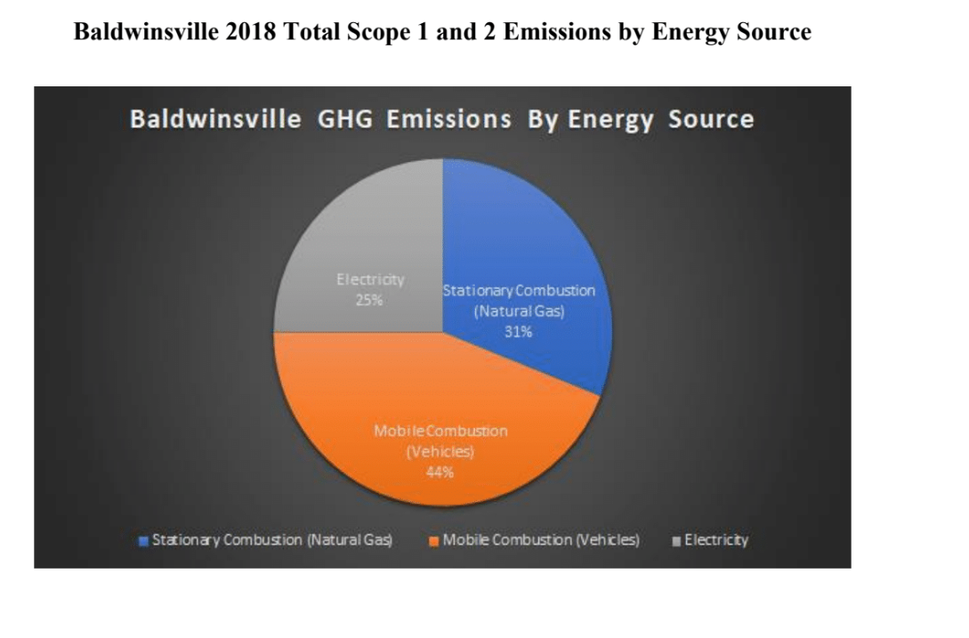
Figure 1. This pie chart shows the three energy sources, stationary combustion (natural gas), mobile combustion (vehicle), and electricity, that make up scope 1 and scope 2 emissions by percentage.

Baldwinsville 2018 Fuel/Energy Use by Department
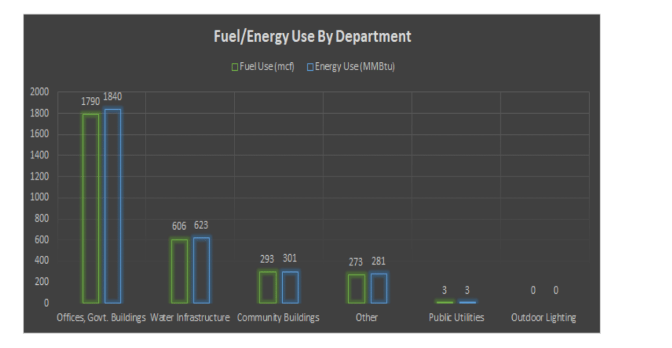Figure 2. This figure shows the fuel use versus energy use in six departments; offices and government buildings, water infrastructure, community buildings, public utilities, outdoor lighting, and other.
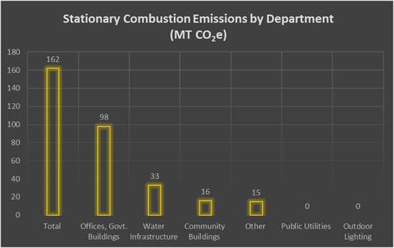
Figure 3. Stationary Combustion Emissions by Department in 2018
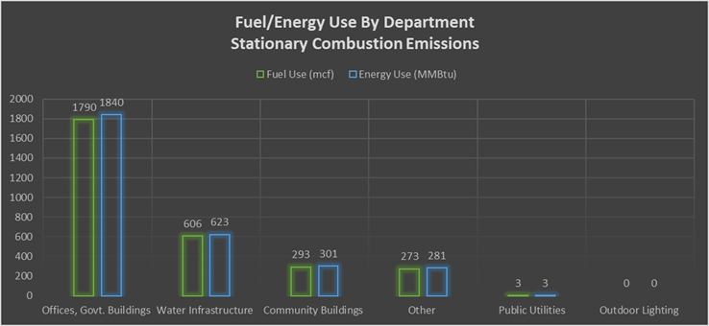
Figure 4. Stationary Combustion Emissions: Fuel/Energy Use by Department in 2018
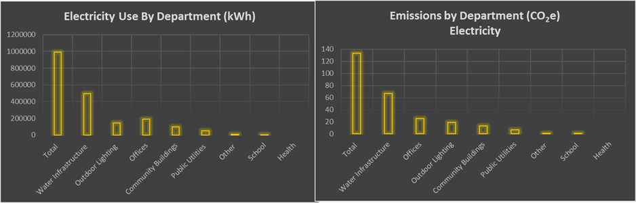
Figure 5. Electricity Use by Department in 2018
Figure 6. Electricity: Emissions by Department in 2018

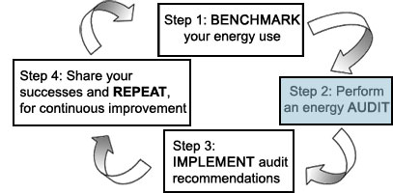
Figure 7. The EPA’s steps to a more energy efficient water system

References
About Beaver Lake – Friends of Beaver Lake Nature Center. (n.d.). Retrieved April 29, 2020, from https://www.beaverlakenaturecenter.org/blnc/
Actions. (n.d.). Retrieved March 9, 2020, from https://climatesmart.ny.gov/actions-certification/actions/
Air Quality Trends Show Clean Air Progress. (2019). US EPA. https://gispub.epa.gov/air/trendsreport/2019/
Businesses. (n.d.). NYSERDA. Retrieved April 9, 2020, from https://www.nyserda.ny.gov/All-Programs/Programs/Energy-Storage/Energy-Storage-for-Your-Business
Bogan, E., Castiglia, D., Cox, H., Esposito, V., Howell, I. Greenhouse Gas Emissions Inventory of the Village of Baldwinsville. SUNY-ESF. May 1, 2019.
Community Choice Aggregation. (n.d.). NYSERDA. Retrieved April 18, 2020, from https://www.nyserda.ny.gov/All-Programs/Programs/Clean-Energy-Communities/Clean-Energy-Communities-Program-High-Impact-Action-Toolkits/Community-Choice-Aggregation
Community Solar With No Rooftop Panels | Nexamp. (n.d.). Retrieved April 9, 2020, from https://solar.nexamp.com/
Denchak, M. (2017). Global Climate Change: What You Need to Know. NRDC. https://www.nrdc.org/stories/global-climate-change-what-you-need-know
Energy Efficiency for Water Utilities. (2020, May 01). Retrieved May 01, 2020, from https://www.epa.gov/sustainable-water-infrastructure/energy-efficiency-water-utilities
ENERGY STAR. (n.d.). ENERGY STAR Rebate Finder. https://www.energystar.gov/rebate-finder?scrollTo=0&sort_by=utility&sort_direction=asc&page_number=0&lastpage=0&zip_code_filter=&find_rebates=Find+Rebates&search_text=13027&product_clean_isopen=&product_types=Select+a+Product+Category
ENERGY STAR. (2020, April). ENERGY STAR Energy-saving tips. https://www.energystar.gov/buildings/facility-owners-and-managers/existing-buildings/communicate-your-success/energy-star-communications-toolkit/bring-your-green-work-1
EPA. (2019). Using Trees and Vegetation to Reduce Heat Islands. Retrieved April 19, 2020, from https://www.epa.gov/heat-islands/using-trees-and-vegetation-reduce-heat-islands
Green Mountain Energy Company | Renewable Energy Provider. (n.d.). Green Mountain Energy Company. Retrieved April 9, 2020, from https://www.greenmountainenergy.com/
Impacts of Climate Change in New York—NYS Dept. Of Environmental Conservation. (n.d.). Retrieved April 9, 2020, from https://www.dec.ny.gov/energy/94702.html
Interior Department Finalizes Rule Providing a Foundation for the Future of BLM’s Renewable Energy Program. (2016, November 10). https://www.doi.gov/pressreleases/interior-department-finalizes-rule-providing-foundation-future-blms-renewable-energy
Kelly, C., Martinez, C., & Hathaway-Williams, W. (n.d.). A Framework for Local Action on Climate Change. Center for American Progress. Retrieved April 9, 2020, from https://www.americanprogress.org/issues/green/reports/2017/09/28/439712/framework-local-action-climate-change/
Misbrener, K. (2019, June 25). Six New York towns form CCA to procure 100% renewable energy. Solar Power World. https://www.solarpowerworldonline.com/2019/06/six-new-york-towns-form-cca-100-percent-renewable-energy/
National Grid. (2020, April). EPA Portfolio Manager—Upstate NY. https://www.nationalgridus.com/Upstate-NY-Business/Landlords-Property-Managers/EPA-Portfolio-Manager
NYSERDA Announces New Municipal Solar Toolkit to Aid Municipalities in Developing Solar Projects on Underutilized Land—NYSERDA. (2018, August 22). New York State. https://www.nyserda.ny.gov/About/Newsroom/2018-Announcements/2018-08-22-NYSERDA-Announces-New-Municipal-Solar-Toolkit
Program Design, Management, and Implementation. (n.d.). Retrieved May 01, 2020, from https://www.lincusenergy.com/casestudy/program-design-management-implementation/
Renewable energy explained—Incentives—U.S. Energy Information Administration (EIA). (n.d.). Retrieved April 9, 2020, from https://www.eia.gov/energyexplained/renewable-sources/incentives.php
Walton, R. (2018, January 25). New York regulators greenlight third CCA program. Utility Dive. https://www.utilitydive.com/news/new-york-regulators-greenlight-third-cca-program/515595/
Water and Energy Efficiency at Utilities and in the Home. (2019, November 21). Retrieved May 01, 2020, from https://www.epa.gov/sustainable-water-infrastructure/water-and-energy-efficiency-utilities-and-home
United States Environmental Protection Agency. (2017). Guide to Greenhouse Gas Management for Small Business & Low Emitters. https://www.epa.gov/sites/production/files/2017-01/documents/guide_to_greenhouse_gas_management_for_small_business_low_emitters.pdf
United States Environmental Protection Agency. (2020). ENERGY SAR Guidelines for Energy Management. https://www.energystar.gov/sites/default/files/buildings/tools/Guidelines%20for%20Energy%20Management%206_2013.pdf
ZDNet.com. (2011, August 10). IGo Green Power Smart Tower. IGo Green Power Smart Tower. https://www.zdnet.com/article/igo-green-power-smart-tower/
2019 Instructions for Form 5695. (n.d.). 6.

