Village of Fayetteville, New York

Municipal Operations and Community Greenhouse Gas Inventory Update
Compiled by the Central New York
Regional Planning and Development Board

August 15, 2022

425 East Genesee Street

Fayetteville, NY 13066

This GHG inventory update was compiled by the Central New York Regional Planning and Development Board (CNY RPDB) in support of the village’s Climate Smart Communities and Clean Energy Communities efforts. Contributors include:

- Principal Authors: Amanda Mazzoni, Principal Planner; CNY RPDB, and Michael Boccuzzi, Planner; CNY RPDB,
- Chris Carrick, Energy Program Manager; CNY RPDB,
- Lorie Corsette, Clerk; Village of Fayetteville, and
- Eli Yewdall, Senior Program Officer; ICLEI USA.
Table of Contents
I. Introduction 4
Background 4
Climate Change and Greenhouse Gases 5
New York State GHG Emissions and Climate Goals 6
The Purpose of a Greenhouse Gas Inventory 8
Village Profile 9
II. Data Collection and Analysis 9
Reporting 10
III. Municipal Operations Emissions Inventory 10
Overall Results 10
Buildings and Facilities 12
Methods and inputs 12
Results 13
Streetlights 13
Methods and inputs 13
Results 13
Vehicle Fleet 14
Methods and inputs 14
Results 14
Water Delivery Facilities 14
Methods and inputs 14
Results 14
IV. Community Emissions Inventory 14
Overall Results 14
Residential Sector 16
Methods and inputs 16
Results 16
Commercial/Industrial Sector 17
Methods and inputs 17
Results 18
Transportation Sector 19
Methods and inputs 19
Results 21
Waste Sector 24
Methods and inputs 24
Results 24
Wastewater Sector 25
Methods and inputs 25
Results 25
V. Municipal Operations Emissions Forecast 25
Methods and inputs 25
Results 26
Discussion 26
VI. Community Emissions Forecast 27
Methods and inputs 27
Results 27
Discussion 28
VII. Discussion: 2009 vs 2019 Inventory 31
Municipal Comparison 32
Community Comparison 32
VIII. Conclusion 33
IX. Bibliography 34

I. Introduction

Background
The Climate Smart Communities Program represents a partnership between New York State and local governments to reduce energy use and GHG emissions while working to adapt to a changing climate. The required ten elements of the Climate Smart Communities Pledge are:

- Build a climate-smart community.
- Inventory emissions, set goals, and plan for climate action.
- Decrease energy use.
- Shift to clean, renewable energy.
- Use climate-smart materials management.
- Implement climate-smart land use.
- Enhance community resilience to climate change.
- Support a green innovation economy.
- Inform and inspire the public.
- Engage in an evolving process of climate action.

The Village of Fayetteville adopted the ten-element Climate Smart Communities Pledge as a commitment to greenhouse gas (GHG) emission reduction and climate change adaptation in September 2009, and it is working towards becoming a Bronze Certified Climate Smart Community. The Climate Smart Communities Certification program recognizes communities that have gone beyond the ten pledge elements by completing and documenting mitigation and adaptation actions at the local level. Certified communities are the foremost leaders in the state in terms of climate action. Communities can achieve certification at the Bronze, Silver, or Gold (currently in development) level.

As part of the village’s efforts to become a Certified Climate Smart Community, the village decided to compile a community and municipal GHG inventory update using a baseline of 2019. A GHG emissions inventory is an audit of activities that contribute to the release of emissions and acts as a baseline for a Climate Action Plan. The original GHG inventory was completed for the village in April 2013 with a baseline of 2009, and their Climate Action Plan was completed in December 2014.

It is important to note that the information provided in this inventory is not meant to be exhaustive, but rather to provide an estimate of community and municipal emissions data at one snapshot in time, 2019. The inventory information will inform climate action planning efforts in the village moving forward. This inventory will act as a baseline for tracking and understanding trends associated with future GHG mitigation efforts.

For the municipal operations GHG inventory, energy used by buildings and facilities, streetlights, water and sewer facilities, and the vehicle fleet were gathered for the 2019 year, and for the community GHG inventory, residential energy use, commercial/industrial energy use, transportation, waste generation, and wastewater treatment information were gathered for the 2019 year. Methods of calculation explained in the U.S. Community Operations Protocol were utilized to generate emissions figures. Data was entered into the ClearPath tool, outputs were aggregated into metric tons of CO₂ equivalent, and emissions were delineated by sector, source, and scope (for municipal emissions).

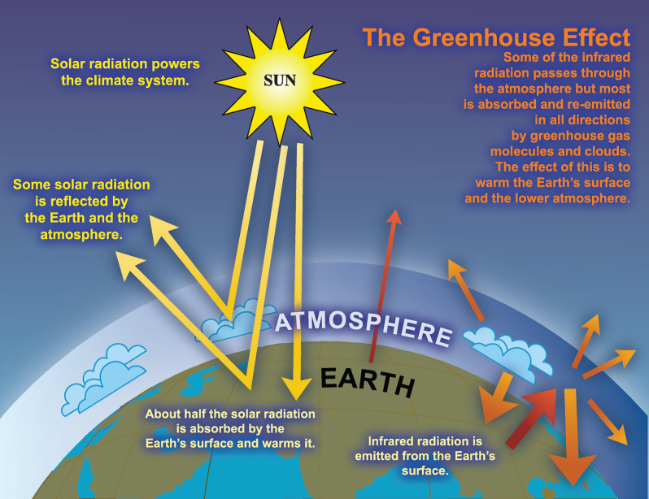

Climate Change and Greenhouse Gases
Climate change is recognized as a global concern. Scientists have documented changes to the Earth’s climate including the rise in global average temperatures, as well as sea levels, during the last century. An international panel of leading climate scientists, the Intergovernmental Panel on Climate Change (IPCC), was formed in 1988 by the World Meteorological Organization and the United Nations Environment Program to provide objective and up-to-date information regarding the changing climate. In its 2014 Fifth Assessment Report, the IPCC states that there is a greater than 95 percent chance that rising global average temperatures, observed since the mid-20th century, are primarily due to human activities. Evidence of observed changes in extremes such as heatwaves, heavy precipitation, droughts, and tropical cyclones, and, in particular, their attribution to human influence, has strengthened since the Fifth Assessment Report, as noted in the Sixth Assessment Report AR6 Climate Change: The Physical Science Basis study published in August 2021.
Figure 1: The Greenhouse Effect

The rising trend of human-generated GHG emissions is a global threat. The increased presence of these gases affects the warming of the planet by contributing to the natural greenhouse effect, which warms the atmosphere and makes the earth habitable for humans and other species (see Figure 1). Mitigation of GHGs is occurring in all sectors as a means of reducing the impacts of this warming trend. However, scientific models predict that some effects of climate change are inevitable no matter how much mitigative action is taken now. Therefore, climate mitigation actions must be paired with adaptation measures in order to continue efforts to curb emissions contributions to global warming, while adapting communities so that they are able to withstand climate change impacts and maintain social, economic, and environmental resilience in the face of uncertainty. Climate adaptation can take shape through infrastructure assessments and emergency planning, as well as through educational efforts to raise public awareness about potential climate change impacts.

New York State outlined projected climate impacts and vulnerabilities during the 2011 ClimAid assessment and 2014 supplement (ClimAid Report). The ClimAid Report projects changes to ecosystems (e.g., increased presence of invasive species and shifts in tree composition), while water quality and quantity may also be impacted due to changes in precipitation. Potential beneficial economic impacts were also identified, such as a longer recreation season in the summer, and a longer growing season for the agricultural sector due to rising temperatures. Scientific evidence suggests that the impacts of global climate change will be different in various regions, and will include temperature shifts, more extreme heat events, sea level rise and coastal flooding, more frequent intense precipitation events, and human health risks.

We have already experienced the effects of a changing climate in New York State and abroad, the need for climate action and adaptation is imperative. The goal of building community resilience in order to protect the health and livelihood of residents and natural systems serves as a motivating factor in the assessment of greenhouse gas contributions and effective sustainability planning.

New York State GHG Emissions and Climate Goals
According to the July 2019 New York State Greenhouse Gas Inventory: 1990-2016 report prepared by the New York State Energy Research and Development Authority (NYSERDA), 2016 state emissions were equal to 206 million metric tons of carbon dioxide equivalent (MMTCO₂e), the majority of which came from energy-related sources (173 MMTCO₂e) compared to non-energy sources (33 MMTCO₂e). Of the energy-related emissions sources, 36% were from transportation, 30% from on-site fuel combustion from buildings, 15% from electricity generation, and 3% from other sources such as fugitive emissions from fossil fuel infrastructure and incineration of municipal waste (see Figure 2).

In July 2019, Governor Cuomo signed the Climate Leadership and Community Protection Act (CLCPA) into law. The CLCPA is New York State’s ambitious emissions reduction plan with the goal of making electricity 70% renewable by 2030 and 100% carbon neutral by 2040, reducing GHG emissions 40% below 1990 levels by 2030 and 85% below 1990 levels by 2050, implementing 6,000 MW of solar by 2025, 3,000 MW of energy storage by 2030, and 9,000 MW of offshore wind by 2035 (see Figure 3).

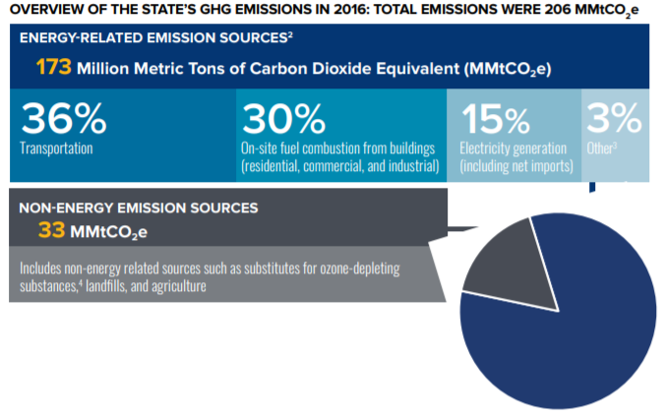
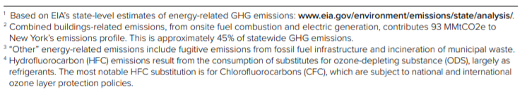
Figure 2: Overview of the State’s GHG Emissions in 2016

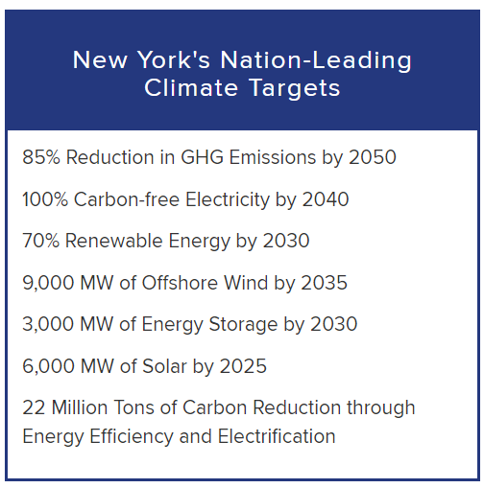
Figure 3: Overview of the CLCPA targets

The Purpose of a Greenhouse Gas Inventory
Many local governments have decided to gain a detailed understanding of how their emissions and their community’s emissions are related to climate change and have committed to reducing GHG emissions at the local level. Local governments exercise direct control over their own operations and can lead by example by reducing energy usage in municipal facilities, using alternative fuels for their fleets, and investing in renewable energy sources. Local governments can also influence community-wide activities that contribute to climate change by improving building codes and standards, providing cleaner transportation options, and educating members of the community about their choices as consumers. Each local government is unique with its own set of opportunities, challenges, and solutions, and therefore climate action needs to be tailored to each community at the local level.

Because local governments typically contribute less than ten percent of the total greenhouse gas emissions generated in a given community, it is recommended that local governments develop both local government operations and community-wide greenhouse gas emissions inventories and reduction strategies. Before concerted management and reduction of greenhouse gas emissions can occur within our local governments and communities, local governments must undertake measurement and analysis of all GHG sources. This report includes a GHG inventory update for both municipal operations and the community-at-large for the 2019 year.

It is important to note that this inventory represents an estimate of emissions for the Village of Fayetteville for the 2019 year, and that the purpose of this inventory is to gain a general baseline of emissions upon which the village can work from for climate action planning purposes. This inventory includes a number of assumptions and estimations, and the methods used to establish this baseline will not necessarily be the same methods used to measure progress.

There are several major benefits to compiling emissions inventories:

- Fiscal benefits: Developing climate and energy strategies can help reduce energy costs and save taxpayer dollars. Conducting a GHG emissions inventory will explain exactly how energy is being used and identify opportunities to become more efficient.

- Climate leadership: By taking action now to address climate change, local governments and elected officials can be recognized for their leadership on climate and energy issues.

- Community benefits: Measures to reduce GHG emissions and energy consumption typically have many co-benefits. They can improve air quality and public health, stimulate the local economy, create green jobs, and make communities more livable and walkable.

- Regulatory preparedness: Taking action now will help your jurisdiction prepare for any future legislative requirements and position your local government for successful compliance.

Village Profile
The Village of Fayetteville is located in eastern Onondaga County. The village covers an area of approximately 1.7 square miles and is located within the Town of Manlius. According to the 2019 American Community Survey, the village has a population of about 4,095 residents, with 1,742 occupied housing units. This is a 5.84% decrease compared to the 2010 United States Census, where the Village had a population of 4,349 residents. This trend is expected to continue with an estimated 0.67% yearly decrease in population size.

II. Data Collection and Analysis
For the municipal inventory update, information related to building and facilities, streetlights, and vehicle fleet were collected for the Fayetteville municipal operations for the 2019 year following the Local Government Operations Protocol. Specific data collection methods for each sector are explained within each section of this report.

For the community inventory update, information related to residential, commercial/industrial, transportation, waste, and wastewater were collected for the Fayetteville community for the 2019 year following the U.S. Community Protocol. Specific data collection methods for each sector are explained within each section of this report.

The ICLEI ClearPath tool was utilized to convert the information into emissions data measured in metric tons of carbon dioxide equivalent (MTCO₂e). The online tool streamlines the process of converting different sources, units, and varieties of emissions into comparable energy use and emissions figures.

Reporting
The three most prevalent greenhouse gases, and therefore the focus of this analysis, are carbon dioxide (CO₂), methane (CH₄) and nitrous oxide (N₂O). The unit used to discuss these gases in aggregate is carbon dioxide equivalent (CO₂e), which is a conversion based on each gas’s Global Warming Potential (GWP), or the impact of 1 unit of each gas in the atmosphere compared to 1 unit of CO₂ (see Table 1). This inventory uses the 20-year GWP values published by the IPCC’s 5th Assessment Report. A discussion of emissions using the IPCC’s 2nd Assessment Report is also included later in this report since these were the GWPs used in the 2013 inventory report.

Greenhouse Gas (GHG) | Global Warming Potential (GWP)
Carbon Dioxide (CO₂) | 1
Methane (CH₄) | 85
Nitrous Oxide (N₂O) | 264

Table 1: IPCC 5th Assessment 20-year Global Warming Potential Values

Emissions are reported by sector and source in the community inventory update and also by scope for the municipal update. Sectors are included or excluded in the boundaries of GHG inventories based on availability of data, relevance to emissions totals, and scale to which they can be changed. The municipal inventory update includes emissions for the buildings and facilities, streetlights, and vehicle fleet sector. The community inventory update includes emissions for the residential, commercial/industrial, transportation, waste, and wastewater sectors. Commercial and industrial sectors are combined due to availability of data from the Utility Energy Registry (UER), which combines commercial/industrial electricity and natural gas use into what it refers to as the “business” sector. Emissions data is also reported by source, including electricity, natural gas, fuel oil, propane, gasoline, and diesel.

III. Municipal Operations Emissions Inventory

Overall Results
In 2019, the Village of Fayetteville’s municipal emissions totaled 519 MTCO₂e. The vehicle fleet sector contributed to the largest percentage of emissions, accounting for 286 MTCO₂e, or 55% of the government’s total emissions. Buildings and facilities were the second largest emitting sector, producing 223 MTCO₂e, or 43% of total municipal emissions, followed by streetlights and traffic signals which produced 10 MTCO₂e, or 2% of total emissions. There were no emissions from wastewater facilities as the Village no longer owns or operates any wastewater facilities or pumps and Onondaga County Department of Water Environment Protection (WEP) provides maintenance services for sewer districts in the Village.. Since the previous GHG inventory was compiled, the Village has replaced electric water pumps with non-electric gravity pumps.

Figure 4: 2019 Municipal Emissions by Sector

The largest source of municipal emissions in the Village of Fayetteville in 2019 was diesel, accounting for 254 MTCO₂e, or 49% of all community emissions. Natural gas was also a large emitting source, producing 176 MTCO₂e (34%).

Figure 5: 2019 Municipal Emissions by Source

The majority (89%) of municipal emissions were scope 1 emissions. Scope 1 emissions are those that are directly emitted by the government onsite, including stationary combustion and vehicle fleet emissions, as well as wastewater process emissions since the treatment facility is located within the municipality and is under municipal control. Scope 2 emissions are those that are indirectly emitted by the government through energy created elsewhere, such as electricity. Scope 3 emissions are other indirect emissions not included in scope 2, such as emissions from wastewater, solid waste processes, or employee commute. Scope 3 emissions were not included in this inventory update primarily due to lack of data.

Figure 6: 2019 Municipal Emissions by Scope

Buildings and Facilities

Methods and inputs
Building and facility electricity and natural gas usage for 2019 was collected using National Grid and New York State Municipal Energy Consortium (NYSMEC) bills. This sector includes all municipal accounts that are not streetlights or related to water and sewer facilities. There were no delivered fuels used in this sector in 2019.

Building and facility energy uses were entered into ClearPath using standard emissions factors for natural gas and propane, and the Environmental Protection Agency (EPA)’s Emissions & Generation Resource Integrated Database (eGRID) factors for NPCC Upstate NY from 2019 were used for electricity emissions calculations (see Table 2 below).

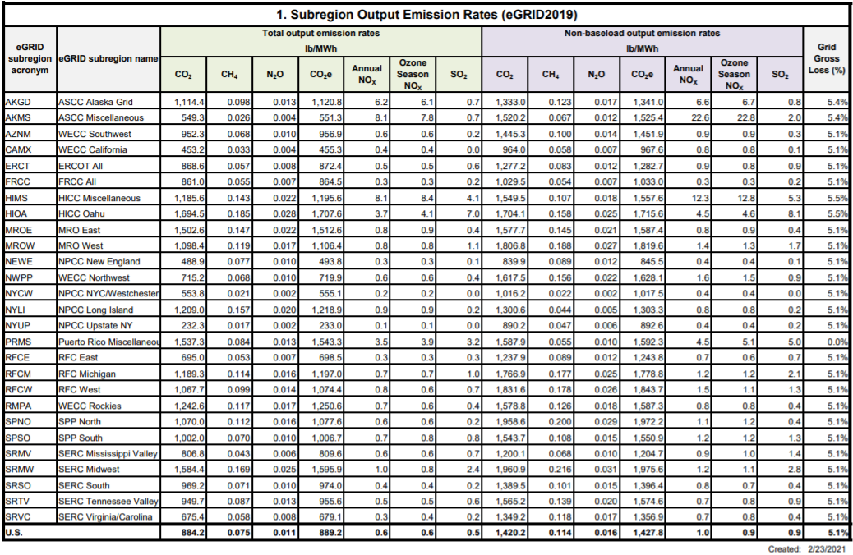
Table 2: eGRID2019 Summary Table: Subregion Emissions

Results
Building and facilities electricity consumption in 2019 was 435,953 kWh and natural gas consumption was 32,992 therms. Building and facilities emissions from electricity in 2019 were 46 MTCO₂e, and emissions from natural gas were 176 MTCO₂e. Overall building and facilities emissions in 2019 were 223 MTCO₂e.

Streetlights

Methods and inputs
Streetlight electricity for 2019 was estimated using streetlight counts as noted on the few National Grid bills that were available for 2019 and using National Grid’s streetlight tariff to estimate kWh based on billable wattage and assumed burn hours. Streetlight energy use was entered into ClearPath using eGRID 2019 factors.

Results
Streetlight electricity consumption in 2019 was 91,806 kWh, a total of 10 MTCO₂e.

Vehicle Fleet

Methods and inputs
Gasoline and diesel fuel use for 2019 was collected from the Village of Fayetteville and entered into ClearPath using standard emissions factors for diesel. Gasoline was entered into ClearPath assuming a standard 10% ethanol blend.

Results
Vehicle fleet gasoline consumption in 2019 was 4,050 gallons (32 MTCO₂e), and diesel use totaled 24,885 gallons (254 MTCO₂e). Vehicle Fleet emissions totaled 286 MTCO₂e in 2019.

Wastewater Facilities

Methods and inputs
The Village no longer operates any wastewater or pumping facilities. Previously electric-powered pumping has been converted to gravity-flow systems. Therefore, this sector is not included in this inventory.

IV. Community Emissions Inventory

Overall Results
In 2019, the Village of Fayetteville’s community emissions totaled 25,052 MTCO₂e. The residential energy use sector contributed to the largest percentage of emissions, accounting for 11,815 MTCO₂e, or 47% of the community’s total emissions. Transportation was the next highest emitting sector, producing 7,568 MTCO₂e, or 30% of total community emissions, followed by the commercial/industrial energy use sector, which produced 4,411 MTCO₂e, or 18% of total emissions. The waste sector emitted 1,170 MTCO₂e, or 5% of emissions, followed by the wastewater sector which contributed 88 MTCO₂e, or 0.3% of emissions.

Figure 7: 2019 Community Emissions by Sector

The largest source of community emissions in the Village of Fayetteville in 2019 was natural gas, accounting for 12,407 MTCO₂e, or 50% of all community emissions. Gasoline was also a large emitting source, producing 5,348 MTCO₂e (21%).

Figure 8: 2019 Community Emissions by Source

Residential Sector

Methods and inputs
Residential electricity and natural gas usage for 2019 was collected using the Utility Energy Registry (UER), which was developed pursuant to the Order Adopting the Utility Energy Registry, issued by the New York State Public Service Commission on April 20, 2018. The UER “standardizes and crowdsources data directly from utilities,” and “was developed by NYSERDA to provide local communities data they need to develop greenhouse gas (GHG) inventories and to track progress towards climate goals.”

Residential propane and fuel oil use were compiled using the 2019 American Community Survey 5-Year Estimates tables for Selected Housing Characteristics which indicate house heating fuels within the Village of Fayetteville. This information was compared to New York State data for household heating fuel, also from the 2019 American Community Survey 5-Year Estimates tables, and amount/type of fuel consumed within the state (according to the US Energy Information Administration (EIA)’s 2019 Residential Energy Consumption Estimates) to calculate estimated heating fuel use within Village of Fayetteville homes.

Residential energy uses were entered into ClearPath using standard emissions factors for natural gas, propane, and fuel oil. eGRID factors for NPCC Upstate NY from 2019 were used for electricity emissions calculations (as explained above).

Results
Residential electricity consumption in 2019 was 15,912,171 kWh; residential natural gas consumption was 1,800,268 therms; residential propane consumption was estimated at 2,871 MMBtu; and residential fuel oil consumption was estimated at 4,237 MMBtu. Residential emissions from electricity in 2019 were 1,692 MTCO₂e; emissions from residential natural gas were 9,626 MTCO₂e; emissions from propane were 180 MTCO₂e; and emissions from fuel oil were 318 MTCO₂e. Overall residential emissions in 2019 were 11,815 MTCO₂e.

Figure 9: 2019 Residential Emissions by Source

Commercial/Industrial Sector

Methods and inputs
Commercial/industrial electricity and natural gas usage for 2019 were gathered from the National Grid UER data for 2019, under the Business field (which includes non-residential customers).

Commercial/industrial propane and fuel oil use were estimated by assuming the proportion of residential homes using propane and fuel oil within the Village of Fayetteville is equal to the proportion of commercial square footage within the Village of Fayetteville using propane and fuel oil.

The proportion of residential homes using propane and fuel oil was determined from the 2019 American Community Survey 5-Year Estimates tables for Selected Housing Characteristics, which indicate house heating fuels within the Village of Fayetteville, compared to total occupied housing units within the village. These ratios were multiplied by the estimated commercial square footage within the Village of Fayetteville to come up with the estimated commercial/industrial space within the village that uses fuel oil and propane.

Commercial/industrial square footage in the Village of Fayetteville was estimated using commercial floor space per worker from the US EIA’s Commercial Buildings Energy Consumption Survey (CBECS) information for 2012 (this was the most recent year with data available), multiplied by the total number of nonfarm workers in the Village of Fayetteville according to the American Community Survey 2019 5-year tables for Occupation by Sex for the Civilian Employed Population 16 Years and Over (including all employed minus natural resources, construction, and maintenance occupations).

Commercial square footage in the Village of Fayetteville using fuel oil and propane were then compared to commercial square footage using fuel oil and propane within New York State. Total commercial floor space within New York was calculated using EIA’s Commercial Buildings Energy Consumption Survey (CBECS) for 2012 (this was the most recent year with data available), multiplied by the total number of nonfarm workers as per the American Community Survey 2019 5-year tables for Occupation by Sex for the Civilian Employed Population 16 Years and Over (including all employed minus natural resources, construction, and maintenance occupations) for New York State. Fayetteville commercial/industrial space using fuel oil and propane were then compared to the statewide proportion of households using fuel oil and propane from the statewide American Community Survey. That ratio was then multiplied by the total fuel use within New York State (from the EIA’s State Energy Data System (SEDS) 2019 report) to come up with the total commercial/industrial fuel oil and propane use within the Village of Fayetteville. These calculations are explained in detail within the CNY RPDB’s data collection and analysis workbooks for this inventory.

Commercial energy uses were entered into ClearPath using the default emissions factors for natural gas, propane, and fuel oil. Similar to the residential electric analysis, the EPA’s eGRID factors from 2019 was used for electricity emissions calculations for the commercial/industrial sector.

Results
Commercial/industrial electricity consumption in 2019 was 13,521,470 kWh; commercial/industrial natural gas consumption was 520,006 therms; commercial/industrial propane consumption was estimated at 830 million British Thermal Units (MMBtu); and commercial/industrial fuel oil consumption was 1,881 MMBtu. Commercial/industrial emissions from electricity in 2019 were 1,437 MTCO₂e; emissions from commercial/industrial natural gas were 2,781 MTCO₂e; emissions from propane were 52 MTCO₂e; and emissions from fuel oil were 141 MTCO₂e. Total emissions from the commercial/industrial sector in 2019 were 4,411 MTCO₂e.

Figure 10: 2019 Commercial/Industrial Emissions by Source

Transportation Sector

Methods and inputs
Transportation emissions were estimated using estimated annual vehicle miles traveled (AVMT), 2019 U.S. National Default emissions factors (updated 2021 – see Table 3 below), and estimates for percentage of vehicle types. Transportation emissions were broken down for diesel and gasoline, assuming a standard 10% ethanol blend in gasoline.

AVMT for 2019 was calculated by multiplying available Annual Average Daily Traffic (AADT) counts from 2019 by road lengths within the Village of Fayetteville and multiplying total daily VMT by 365 days per year.

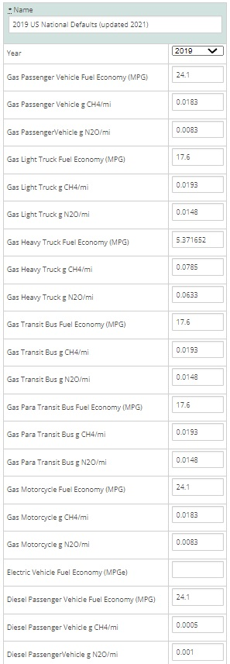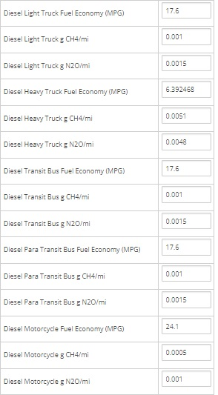
Table 3: 2019 US National Default Transportation Emissions

AADT counts were primarily only available for main arteries; therefore, additional calculations for AADT were needed to estimate AVMT for local/collector roads, as well as some main arteries that do not have AADTs available. The total length of roads in Fayetteville with traffic counts is 6.251 miles, while 18.069 miles of roads do not have AADT counts available.

According to the Minimum Maintenance Standards Regulation 239/02, a set of guidelines produced by the Association of Municipalities of Ontario to help local communities estimate traffic volume, while conducting an AADT count, it is possible to estimate the traffic volume for dead-ends and cul-de-sacs to avoid resource intensive counts. This is done by multiplying the number of houses on the roadway by a factor of 6 for rural areas.

This method was applied to the Village of Fayetteville for the roads without AADT counts since most of these roads were local/collector roads. It was determined that there were 1,742 occupied households in the Village of Fayetteville in 2019, according to the American Community Survey. It was assumed that all homes are on roadways that do not have a count, since most houses are on local/collector roads. By multiplying the number of occupied homes by 6, a combined AADT count of 10,452 was calculated for all 18.069 miles of roads without AADT counts available. In order to calculate VMTs, an average AADT value was needed, and derived by dividing the total AADT by the 18.069 miles of uncounted roadway. This gave an average AADT value of 578.4 for 2019, which was applied to all roadways that did not have a count.

Results
AVMT for roads with AADT counts available in 2019 totaled 11,840,073, while AVMT for roads without AADT counts available in 2019 totaled 3,814,980. Total AVMT in 2019 was 15,655,053.

BeginDescr | EndDescrip | RoadwayNam | Calculatio | AADT | RCSTAYearD | Length_Mi | VMT
NY 5 | MANLIUS V/L | DUGUID ROAD | 2019 | 1467 | 331006, 2019, CT | 0.230997 | 338.87
RT 5 FAYETTEVILLE | RT 290 END RT 257 |  | 2019 | 4322 | 330374, 2019, CT | 0.474957 | 2052.76
TOWN OF MANLIUS VILLAGE OF F | HIGHBRIDGE RD |  | 2019 | 22698 | 330109, 2019, CT | 0.110000 | 2496.78
END 5/92 OLAP | TOWN OF MANLIUS VILLAGE OF F |  | 2019 | 23166 | 330106, 2019, CT | 0.009088 | 210.53
HIGHBRIDGE RD | SALT SPRINGS RD |  | 2019 | 21309 | 330096, 2019, CT | 0.440000 | 9375.96
RT 92 MANLIUS | RT 5 FAYETTEVILLE |  | 2019 | 6331 | 330179, 2019, CT | 0.547070 | 3463.50
RT 257 | DUGUID RD |  | 2019 | 8751 | 330178, 2019, CT | 0.861471 | 7538.73
SALT SPRINGS RD | RT 257 |  | 2019 | 15499 | 330177, 2019, CT | 0.080000 | 1239.92
VILLAGE LINE S | NY 5 | HIGHBRIDGE ST | 2019 | 5044 | 332102, 2019, CT | 0.498994 | 2516.93
GRIFFIN ST | HIGHBRIDGE ST | S BURDICK ST | 2019 | 10 | 335205, 2019, CT | 0.076089 | 0.76
S MANLIUS ST | WELLWOOD DR | FRANKLIN ST E | 2019 | 352 | 335204, 2019, CT | 0.160880 | 56.63
GENESEE ST | ELM ST | EDWARDS ST | 2019 | 75 | 335203, 2019, CT | 0.095178 | 7.14
CLINTON ST | ORCHARD ST | WALNUT ST | 2019 | 200 | 336072, 2019, CT | 0.080143 | 16.03
SPRING ST | S MANLIUS ST | FRANKLIN ST W | 2019 | 744 | 336071, 2019, CT | 0.229149 | 170.49
NY5 GENESEE ST | BROOKLEA DR | LIMESTONE PLAZA | 2019 | 3609 | 336159, 2019, CT | 0.130000 | 469.17
BROOKLEA DR | VILLAGE LINE | FEEDER ST | 2019 | 12 | 336180, 2019, CT | 0.227616 | 2.73
BRIAR BROOK RUN | CUL-DE-SAC | FRONT ROYAL CT | 2019 | 109 | 335456, 2019, CT | 0.139985 | 15.26
REDFIELD AVE | BISHOP | FAIRFIELD ST | 2019 | 83 | 335442, 2019, CT | 0.280030 | 23.24
SALTSPRING RD | END | FIELDSTONE DR | 2019 | 53 | 335433, 2019, CT | 0.087705 | 4.65
LINCOLN ST | N PARK ST | WARREN ST | 2019 | 540 | 335427, 2019, CT | 0.069981 | 37.79
CLINTON ST | ORCHARD ST | WARREN ST | 2019 | 551 | 335426, 2019, CT | 0.069986 | 38.56
BROOKSIDE LA | WOODMANCY LA | VANIDA LA | 2019 | 409 | 335425, 2019, CT | 0.149973 | 61.34
HIGHBRIDGE ST | END | THOMPSON ST | 2019 | 200 | 335424, 2019, CT | 0.067314 | 13.46
ORCHARD ST | LINCOLN ST | SPRING ST | 2019 | 161 | 335423, 2019, CT | 0.089965 | 14.48
WALNUT ST | WARREN ST | SOUTH ST | 2019 | 83 | 335422, 2019, CT | 0.049963 | 4.15
KENNEDY ST | DEAD END | SIMS PL | 2019 | 16 | 335421, 2019, CT | 0.030434 | 0.49
WALNUT ST | CHAPEL ST | S PARK ST | 2019 | 98 | 335420, 2019, CT | 0.086618 | 8.49
GENESEE ST | OAKWOOD ST | REDFIELD AVE | 2019 | 537 | 335419, 2019, CT | 0.129952 | 69.78
WALNUT ST | CHAPEL ST | ORCHARD ST | 2019 | 645 | 335418, 2019, CT | 0.090018 | 58.06
LEDYARD AVE | REDFIELD AVE | OAKWOOD ST | 2019 | 138 | 335417, 2019, CT | 0.069652 | 9.61
WALNUT ST | CHAPEL ST | CLINTON ST | 2019 | 503 | 335416, 2019, CT | 0.089208 | 44.87
N PARK ST | FRANKLIN ST | CHAPEL ST | 2019 | 316 | 335415, 2019, CT | 0.070056 | 22.14
ELM ST | MECHANIC ST | CENTER ST | 2019 | 203 | 335414, 2019, CT | 0.059289 | 12.04
NY 92 | VILLAGE LINE S | HIGHBRIDGE ST | 2019 | 6210 | 338037, 2019, CT | 0.000181 | 1.13
NY 257 | N EAGLE VIL RD | SALT SPRINGS RD | 2019 | 4930 | 332068, 2019, CT | 0.343312 | 1692.53
NY 5 | CEDAR BAY RD | NORTH BURDICK S | 2019 | 13458 | 331267, 2019, CT | 0.025974 | 349.56
 |  |  |  |  |  | Daily VMT total | 32,438.56
 |  |  |  |  |  | 365 days | 365.00
 |  |  |  |  |  | Annual VMT | 11,840,073.37

Table 4: 2019 Village of Fayetteville Traffic Data for Road Segments with Available AADT

# occupied housing units: | 1,742
Total AADT for roads not accounted for above: | 10,452
Days per year: | 365
Average AADT for roads not accounted for above: | 578.4
Total Annual VMT for manually calculated roads: | 3,814,980

Table 5: 2019 Village of Fayetteville Traffic Data for Road Segments without Available AADT

Emissions from transportation in the Village of Fayetteville in 2019 totaled 7,568 MTCO₂e, with 5,348 MTCO₂e from gasoline (10% ethanol) and 2,220 MTCO₂e from diesel.

Figure 11: 2019 Transportation Emissions by Source

Waste Sector

Methods and inputs
Waste emissions from the Village of Fayetteville were calculated using total tons of waste from Onondaga County disposed of at the Onondaga County Resource Recovery Agency’s Waste to Energy Facility and scaling down to the village based on population. Total waste figures were obtained from OCRRA’s 2019 annual report.

County Population | Village of Fayetteville population | Total tons waste from Onondaga County (not including recycling waste) | Tons of waste disposed per person | Tons of waste disposed from Village of Fayetteville
462,872 | 4,095 | 362,653.00 | 0.78 | 3,208.37

Table 6: 2019 Village of Fayetteville Community Waste Estimate

All waste was entered into the “Combustion of Solid Waste Generated by the Community” calculator and calculated using ICLEI’s SW.2.2a methodology.

Results
Waste emissions for the Village of Fayetteville in 2019 totaled 1,170 MTCO₂e.

Wastewater Sector

Methods and inputs
According to Lorie Corsette, Village Clerk, all village residents use public wastewater treatment. Wastewater treatment emissions within the Village of Fayetteville were calculated using the Population Based method in ClearPath and assuming the whole residential population of the village was using public wastewater treatment (4,095 people).

Results
Emissions from wastewater treatment in the Village of Fayetteville totaled 88 MTCO₂e in 2019.

V. Municipal Operations Emissions Forecast

Methods and inputs
A municipal operations emissions forecast is included here to provide a sense of what emissions might look like in 2030 for municipal operations under a business-as-usual scenario. The forecast was compiled using ICLEI’s protocol for forecasting and entering data into the ClearPath tool online. Data from the 2019 municipal inventory above was used as a baseline for this forecast. Compound Average Growth Rates were used to forecast emissions in all sectors using the inputs noted below.

To forecast emissions from the municipal buildings and facilities sector, population growth rates from 2010 to 2019 as well as mandates of the Climate Leadership and Community Protection Act (i.e. 70% electricity from renewables by 2030) were used. It is assumed that as population of the village decreases, energy used by municipal operations at buildings and facilities decreases in a proportional manner.

To forecast emissions from municipal streetlights, mandates of the Climate Leadership and Community Protection Act (i.e. 70% electricity from renewables by 2030) were used. For safety reasons, it is assumed that energy used by streetlights in the village remains constant despite decreasing population.

To forecast emissions from the municipal vehicle fleet, population growth rates as well as Federal rules on vehicle fuel mileage standards were used. It is assumed that as population of the village decreases, energy used by the municipal vehicle fleet decreases in a proportional manner.

Results
Assuming a business-as-usual scenario, emissions in the Village of Fayetteville in 2030 are expected to decrease from 519 MTCO₂e in 2019 to 287 MTCO₂e in 2030, a decrease of about 45%. Each sector’s forecast is explained further below.

Figure 12: Village of Fayetteville Municipal Operations 2030 Emissions Forecast

Discussion
Electric and natural gas used at municipal buildings and facilities is expected to decline slightly in accordance with the village population growth trend (which has decreased very slightly since 2009), but since the Climate Leadership and Community Protection Act requires the state to achieve 70% renewable electricity by 2030, emissions from municipal operations electricity use are expected to drop from 46 MTCO₂e to 13 MTCO₂e. Overall emissions from municipal buildings and facilities are therefore expected to decrease from 223 MTCO₂e in 2019 to 177 MTCO₂e by 2030.

Emissions from municipal vehicles are expected to decrease because the carbon intensity of the vehicle miles traveled is expected to decrease as federal transportation policies require vehicle fuel mileage standards to improve over time. Emissions from municipal vehicle fleet at therefore expected to decrease from 286 MTCO₂e in 2019 to 107 MTCO₂e by 2030.

Emissions from streetlights are expected to decrease from 10 MTCO₂e to 3 MTCO₂e in accordance with CLCPA goals of achieving 70% renewable electricity by 2030.

VI. Community Emissions Forecast

Methods and inputs
A community emissions forecast is included here to provide a sense of what emissions might look like in 2030 under a business-as-usual scenario. The forecast was compiled using ClearPath guidance. Compound Average Growth Rates were used to forecast emissions in all sectors, using the inputs noted below.

To forecast emissions from the residential and commercial/industrial sectors, State energy use trends as described in the 2015 New York State Energy Plan and mandates of the Climate Leadership and Community Protection Act (i.e. 70% electricity from renewables by 2030) were used.

To forecast emissions from the transportation sector, State energy use trends as described in the 2015 New York State Energy Plan and Federal rules on vehicle fuel mileage standards were used.

To forecast emissions from the waste sector, population growth rates for the Village of Fayetteville from the American Community Survey from 2010 vs. 2019 were used, assuming population would continue to decline at a similar rate through 2030 and waste production would increase proportionally to population growth.

To forecast emissions from the wastewater sector, population growth rates for the Village of Fayetteville from the American Community Survey from 2010 vs. 2019 were used, assuming population would continue to grow at a similar rate through 2030 and wastewater emissions would increase proportionally to population growth.

Results

Assuming a business-as-usual scenario, emissions in the Village of Fayetteville in 2030 are expected to decrease from 25,052 MTCO₂e in 2019 to 18,481 MTCO₂e in 2030, a decrease of about 26%. Emissions are expected to decrease in the residential, commercial/industrial, and transportation sectors, and increase in the waste and wastewater sectors. Each sector’s forecast is explained further below.

Figure 13: Village of Fayetteville Community 2030 Emissions Forecast

Discussion

Emissions from the residential sector are expected to decrease from 11,815 MTCO₂e in 2019 to 10,599 MTCO₂e by 2030.

Figure 14: Forecasted Residential Emissions in the Village of Fayetteville for 2030

Since the Climate Leadership and Community Protection Act has set a goal of 70% electricity coming from renewables by 2030, emissions from residential electricity use are expected to drop significantly. Residential propane and fuel oil use are projected to decrease as well, with natural gas use staying about the same, according to the 2015 New York State Energy Plan.

Emissions from the commercial/industrial sector are expected to decrease overall, from 4,411 MTCO₂e in 2019 to 3,577 MTCO₂e by 2030.

Figure 15: Forecasted Commercial/Industrial Emissions in the Village of Fayetteville for 2030

Since the Climate Leadership and Community Protection Act has set a goal of 70% electricity coming from renewables by 2030, emissions from commercial/industrial electricity use are expected to drop significantly. Commercial/industrial fuel oil use is projected to decrease as well, with propane use staying about the same and natural gas use increasing slightly over time, according to the 2015 New York State Energy Plan.

Emissions from the transportation sector are expected to decrease overall as well, from 7,568 MTCO₂e in 2019 to 2,950 MTCO₂e by 2030.

Figure 16: Forecasted Transportation Emissions in the Village of Fayetteville for 2030

According to the 2015 New York State Energy Plan, gasoline and vehicle miles traveled are expected to decrease over time, with diesel use and vehicle miles traveled increasing. However, the carbon intensity of the vehicle miles traveled for all fuel types is expected to decrease as federal transportation policies require vehicle fuel mileage standards to improve over time, so emissions from all fuel sources are expected to decrease.

Emissions from the waste sector are expected to increase slightly, from 1,170 MTCO₂e in 2019 to 21,260 MTCO₂e by 2030. This forecast is directly related to estimated population growth rate in the village.

Emissions from the wastewater sector are expected to increase, from 88 MTCO₂e in 2019 to 95 MTCO₂e in 2030. This forecast is directly related to estimated population growth rate in the village.

VII. Discussion: 2009 vs 2019 Inventory

As noted above, the Village of Fayetteville compiled a greenhouse gas inventory in 2013 with a baseline year of 2009. Below is a discussion comparing emissions for both the municipal operations and the community as reported in 2009 vs this report.

It should be noted that the 2009 inventory was compiled using the current standards at the time, which meant using Global Warming Potentials (GWPs) from the IPCC’s 2nd Assessment Report compared to the current standard of using the 20-year GWPs in IPCC’s 5th Assessment Report. Therefore, Figures 17 and 18 below shows what emissions totals would be for 2019 using the same GWPs as were used to calculate 2009 emissions (noted as “2019 IPCC 2nd”).

The IPCC 2nd assessment report assumes a GWP of 21 for methane over a 100-year period, meaning that the impact of 1 unit of methane in the atmosphere creates 21 times more warming potential than 1 unit of CO₂ over a 100-year time period. However, methane typically remains in the atmosphere for closer to 12 years as opposed to CO₂ which can remain in the atmosphere for over 100 years, meaning that methane’s impact while it remains in the atmosphere is much stronger than that of CO₂. Therefore, the IPCC 5th assessment report includes both a 100 year and 20-year GWP for methane of 28 and 84, respectively. The IPCC 5th assessment report’s 20-year GWP for nitrous oxide is 264 as compared to 310 from the IPCC 4th assessment report, 100-year GWP.

As illustrated in Figures 17 and 18, there is not much difference between the two GWP scenarios for most sectors, but there is a more noticeable increase in emissions for waste and wastewater using the IPCC 5th assessment 20-year GWPs. Therefore, it is important to consider the methodology used in creating this and future inventory updates, as well as when comparing data from this inventory to inventories from other communities.

Municipal Comparison
Table 7 below compares municipal energy use from 2009 to municipal energy use from 2019.
Municipal Energy Use | Source | 2009 | 2019 | Difference
Buildings and Facilities | Electricity (kWh) | 130,273 | 435,953 | 305,680 | 235%
 | Natural gas (therms) | 53,556 | 32,992 | -20,564 | -38%
Streetlights and Traffic Signals | Electricity (kWh) | 229,602 | 91,806 | -137,796 | -60%
Vehicle Fleet | Gasoline (gallons) | 5,423 | 4,050 | -1,373 | -25%
 | Diesel (gallons) | 25,656 | 24,885 | -772 | -3%
Wastewater Facilities | Electricity (kWh) | 4,485 | 0 | -4,485 | -100%

Table 7: Village of Fayetteville Municipal Energy Use 2009 v 2019

In 2009, emissions from the Village of Fayetteville municipal operations totaled 670 MTCO₂e, compared to 519 MTCO₂e in 2019.

Figure 17: Village of Fayetteville 2009 vs 2019 Municipal Emissions

As illustrated in Figure 17, the largest difference in emissions from 2009 to 2019 is in the buildings and facilities sector. The increase in electricity use from 139,273 kWh in 2009 to 435,953 kWh in 2019 can likely be attributed to a significant addition made to the Fire Department, the creation of a bunk-in student program, and addition of overnight shifts. Despite the increase in electricity use, there was still a 30% decrease in emissions from the Buildings and Facilities sector over the ten-year period which can be explained by decreases in emissions factors for electricity as a result of less carbon-intensive sources of electricity being supplied by the state’s utilities. Additionally, natural gas use decreased by 38% during that time. Upgrades to the DPW building, such as air curtains and a new roof, improved the building’s energy efficiency and likely reduced the amount of natural gas needed to heat the building. Another potential cause for this reduction in natural gas use is fewer heating degree days in 2019 compared to 2009. A degree day compares the mean temperature recorded for a location to a standard temperature, usually 65℉. More heating degree days implies greater energy use to heat spaces. In 2009, there were 6,687 heating degree days and in 2019 there were 6,601 heating degree days, so the village likely required less natural gas for building heating.

Emissions from streetlights significantly decreased between 2009 and 2019 because of the reduced energy use since the Village converted all cobra head streetlights to LEDs. The Village is currently in the process of converting decorative streetlights to LEDs as well.

Vehicle fleet emissions decreased slightly in between 2009 and 2019. This could be attributed to a reduction in the vehicle fleet, distance traveled, and improvements in fuel efficiency with newer vehicles.

Community Comparison
Table 8 below compares community energy in 2009 to community energy use in 2019.

Community Energy Use | Source | 2009 | 2019 | Difference
Residential Energy Use | Electricity (kWh) | 15,169,694 | 15,912,171 | 742,477 | 5%
 | Natural gas (therms) | 1,590,582 | 1,800,268 | 209,686 | 13%
 | Propane (MMBtu) | 1,300 | 2,871 | 1,571 | 121%
 | Fuel oil (MMBtu) | 607 | 4,237 | 3,630 | 598%
Commercial/Industrial Energy Use | Electricity (kWh) | 13,193,041 | 13,521,470 | 328,429 | 2%
 | Natural gas (therms) | 555,657 | 520,006 | -35,651 | -6%
 | Propane (MMBtu) | 2,165 | 830 | -1,335 | -62%
 | Fuel oil (MMBtu) | 8,821 | 1,881 | -6,939 | -79%
Transportation | Vehicle Miles Traveled | 22,139,799 | 15,655,053 | -6,484,746 | -29%
Waste | Total tons | 2,953 | 3,208 | 255 | 9%

Table 7: Village of Fayetteville Municipal Energy Use 2009 v 2019

In 2009, emissions from the Village of Fayetteville community totaled 31,389 MTCO₂e, compared to 25,052 MTCO₂e in 2019. It should be noted that the 2015 report was able to separate out Commercial and Industrial emissions due to availability of data at the time, but the two sectors are included in the Commercial/Industrial Use sector in Figure 18 below.

Figure 18: Village of Fayetteville 2009 vs 2019 Community Emissions

As illustrated in Figure 18, emissions in the Residential, Waste, and Wastewater sectors were relatively similar in 2009 and 2019, whereas emissions for Commercial/Industrial and Transportation sectors appear to have decreased. This could be due to a difference in methodology, as Commercial/Industrial energy use for all sources had to be estimated in 2019 and Industrial energy use was not available separately. It could also be due to a decrease in emissions factors for electricity, and for vehicle miles traveled, as vehicles have become more efficient per mile traveled over time.

VIII. Conclusion
This greenhouse gas inventory update can help inform a Climate Action Plan update, which can help the village to better understand energy use and emissions from both municipal operations and the community-at-large.

The results of this study indicate that the largest percentage of municipal emissions came from the vehicle fleet and the largest percentage of community emissions came from the residential sector for 2019. Municipal vehicle fleet emissions should be targeted in the village’s future Climate Action Plan Update so that energy use from this sector can be reduced, therefore lowering both energy costs and GHG emissions. Through the Department of Environmental Conservation (DEC) Municipal Zero-emission Vehicle (ZEV) program, municipalities can earn rebates for purchasing zero-emission vehicles for fleet use, as well as grant funding for charging station infrastructure.

It should be noted that buildings continue to be the largest source of emissions for the community, as it is for the state, and that efforts could be directed towards cleaner sources of heating and cooling, including implementing local community campaigns for clean heating and cooling and energy efficiency, which could be completed in coordination with HeatSmart CNY and with the assistance of the CNY RPDB.

It is recommended that the village participate further in the Clean Energy Communities program and other state and utility incentive programs to help achieve additional energy and emissions savings. The CNY RPDB is available to provide technical assistance to implement projects and to secure grants and other financial support for projects.

As a Climate Smart Community, the Village of Fayetteville has partnered with state and local agencies to combat climate change and pledge to reduce greenhouse gas emissions. Conducting an emissions inventory update is an important step in climate action planning, mitigation, and adaptation. This inventory will provide a benchmark for planning purposes with the goal of setting an emissions reduction target and updating the Village’s Climate Action Plan.

IX. Bibliography

Center for Climate and Energy Solutions. (2020). Federal Vehicle Standards. Retrieved from https://www.c2es.org/content/regulating-transportation-sector-carbon-emissions/.

ICLEI. (2020). ClearPath. Retrieved from https://clearpath.icleiusa.org/.

IPCC. (2014). Fifth Assessment Report. Retrieved from https://www.ipcc.ch/report/ar5/syr/.

IPCC Working Group I. (2007). The Physical Science Basis. Retrieved from https://wg1.ipcc.ch/publications/wg1-ar4/faq/wg1_faq-1.3.html.

Level of Service Policy for Municipal Highways in the United Townships of Head, Clara & Maria. (2008). Retrieved from http://www.townshipsofheadclaramaria.ca/download.php?dl=YToyOntzOjI6ImlkIjtzOjI6 Ijg1IjtzOjM6ImtleSI7aTo0O30=.

NYSERDA. (2014). Climate Change in New York State: Updating the 2011 ClimAID Climate Risk Information. Retrieved from https://www.nyserda.ny.gov/About/Publications/Research%20and%20Development%20 Technical%20Reports/Environmental%20Research%20and%20Development%20Techni cal%20Reports/Response%20to%20Climate%20Change%20in%20New%20York.

NYSERDA. (2019). New York Greenhouse Gas Inventory Fact Sheet. Retrieved from https://www.nyserda.ny.gov/About/Publications/EA-Reports-and-Studies/Energy- Statistics.

NYSERDA. (2021). Utility Energy Registry. Retrieved from
https://utilityregistry.org/app/#/datagrid.

US EIA. (2021). State Energy Data System (SEDS): 1960-2019. Retrieved from https://www.eia.gov/state/seds/seds-data-complete.php#Consumption.

US EIA. (2016). Commercial Buildings Energy Consumption Survey (CBECS). Retrieved from https://www.eia.gov/consumption/commercial/data/2012/#b1-b2.

US EPA. (2021). eGRID 2019 Summary Tables. Retrieved from https://www.epa.gov/egrid/egrid-2019-summary-tables.

The Local Government Operations Protocol and U.S. Community Operations Protocol were developed by ICLEI-Local Governments for Sustainability in order to provide “accounting for GHG emissions associated with local government operated buildings, vehicles, and other operations” and “detailed, cutting-edge guidance on completing a GHG emissions inventory at the community scale in the United States — including emissions from businesses, residents, and transportation,” according to ICLEI’s website.
ClearPath is a proprietary tool developed by ICLEI-Local Governments for Sustainability to assist local governments with conducting greenhouse gas emissions inventories and with the development of local climate action plans.
IPCC. 2014. Fifth Assessment Report. https://www.ipcc.ch/report/ar5/syr/
IPCC. 2021. Sixth Assessment Report Headline Statements from the Summary for Policymakers. https://www.ipcc.ch/report/ar6/wg1/downloads/report/IPCC_AR6_WGI_Headline_Statements.pdf
IPCC Working Group. https://wg1.ipcc.ch/publications/wg1-ar4/faq/wg1_faq-1.3.html
NYSERDA. 2014. Climate Change in New York State: Updating the 2011 ClimAID Climate Risk Information. https://www.nyserda.ny.gov/About/Publications/Research%20and%20Development%20Technical%20Reports/Environmental%20Research%20and%20Development%20Technical%20Reports/Response%20to%20Climate%20Change%20in%20New%20York
NYSERDA. 2014. Climate Change in New York State: Updating the 2011 ClimAID Climate Risk Information. https://www.nyserda.ny.gov/About/Publications/Research%20and%20Development%20Technical%20Reports/Environmental%20Research%20and%20Development%20Technical%20Reports/Response%20to%20Climate%20Change%20in%20New%20York; and National Climate Assessment. 2014. Climate Change Impacts in the United States. https://nca2014.globalchange.gov/.
NYSERDA. Greenhouse Gas Inventory Fact Sheet. https://www.nyserda.ny.gov/About/Publications/EA-Reports-and-Studies/Energy-Statistics.
ICLEI. 2012. U.S. Community Protocol for Accounting and Reporting of Greenhouse Gas Emissions.
The ClearPath tool provides standard emissions factors that were developed by ICLEI and are described in the Local Government Operations Protocol, Appendix G.
US EPA. Emissions & Generation Resource Integrated Database (eGRID). https://www.epa.gov/egrid/summary-data.
The gasoline entry in ClearPath was entered as ethanol with 10% biofuel to account for the typical 10% ethanol blend.
NYSERDA. Utility Energy Registry. https://utilityregistry.org/app/#/
US EIA. State Energy Data System (SEDS): 1960-2019. https://www.eia.gov/state/seds/seds-data-complete.php#Consumption
The ClearPath tool provides standard emissions factors that were developed by ICLEI and are described in the Local Government Operations Protocol, Appendix G.
US EPA. Emissions & Generation Resource Integrated Database (eGRID). https://www.epa.gov/energy/emissions-generation-resource-integrated-database-egrid.
US EIA. Commercial Buildings Energy Consumption Survey (CBECS). https://www.eia.gov/consumption/commercial/data/2012/#b1-b2
US EIA. Commercial Buildings Energy Consumption Survey (CBECS). https://www.eia.gov/consumption/commercial/data/2012/#b1-b2
US EIA. State Energy Data System (SEDS): 1960-2019. https://www.eia.gov/state/seds/seds-data-complete.php#Consumption.
The ClearPath tool provides standard emissions factors that were developed by ICLEI and are described in the Local Government Operations Protocol, Appendix G.
US EPA. Emissions & Generation Resource Integrated Database (eGRID). https://www.epa.gov/energy/emissions-generation-resource-integrated-database-egrid.
As per Eli Yewdall at ICLEI, “The default vehicle factor sets are derived from EIA data for fuel economy, and EPA emissions factors for CH4 and N2O. Because EPA publishes factors by model year, we had to convert those to represent the average mix of new and old vehicles on the road in a particular year; we did this using data from the US National GHG inventory.”
As provided by Eli Yewdall at ICLEI: Gasoline passenger vehicles: 68.6% Deisel passenger vehicles: 0.3% Gasoline light trucks: 19.7% Deisel light trucks: 0.8% Gasoline heavy trucks: 1.4% Deisel heavy trucks: 8.5%
The gasoline entry in ClearPath was entered as ethanol with 10% biofuel to account for the typical 10% ethanol blend.
AADT and road segment length GIS data provided by the NYSDOT Highway Data Services Bureau. These traffic counts include all traffic within the village, including pass-through traffic where the origin and destination of trips occur outside of the village’s boundaries. These trips will be more difficult to address in climate action planning than the trips that begin and/or end within the village.
http://www.townshipsofheadclaramaria.ca/download.php?dl=YToyOntzOjI6ImlkIjtzOjI6Ijg1IjtzOjM6ImtleSI7aTo0O30=
This forecast uses the December 2021 Final Rule to Revise Existing National GHG Emisisons Standards for Passenger Cars and Light Trucks through MY 2026: https://www.epa.gov/regulations-emissions-vehicles-and-engines/final-rule-revise-existing-national-ghg-emissions/ - CO2 (g/mi) for combined fleet.
Since ClearPath requires VMT inputs for municipal vehicle fleet forecasts, National Default Vehicle Fuel Efficiencies provided by ICLEI at https://docs.google.com/spreadsheets/d/1KXmtHoxI-mPXz0ujidtj76woUcK-RN9ITMRy-gMoUls/edit#gid=1929834944 were utilized to calculate estimated VMT for the village’s fleet, using average light trucks for gasoline and heavy duty trucks for diesel.
This forecast uses the March 2020 Safer Affordable Fuel Efficient (SAFE) Vehicles Rule, which projects combined passenger and light duty vehicle fuel efficiency to be 40.4 mpg by 2026, according to https://www.c2es.org/content/regulating-transportation-sector-carbon-emissions/ accessed 10/19/21.
IPCC. Climate Change 2014 Synthesis Report. https://ar5-syr.ipcc.ch/ipcc/ipcc/resources/pdf/IPCC_SynthesisReport.pdf
U.S. Energy Information Administration. 2022. https://www.eia.gov/energyexplained/units-and-calculators/degree-days.php
National Weather Service. https://www.cpc.ncep.noaa.gov/products/analysis_monitoring/cdus/degree_days/

