Town of Manlius, New York
2019 Municipal Greenhouse Gas Inventory

Prepared by: Atif Ali, Cooper Pyle, and Addison Molinaro

Table of Contents
Acknowledgments 3
Climate Smart Communities Certification Program 4
Background and Purpose 4
Town of Manlius 4
Climate Change and New York State 4
Methodology 5
Excluded Data 7
Emissions Sectors 8
Vehicle Fleet 8
Streetlights 9
Buildings & Facilities 10
Discussion and Summary of Findings 11
Recommendations 11
Conclusion 12

Acknowledgments
Our team would like to acknowledge and thank the following people and organizations for their contributions.
Town of Manlius, New York
The Town of Manlius Board
Central New York Regional Planning and Development Board
Amanda Mazzoni
SUNY College of Environmental Science and Forestry
Dr. Joshua Cousins
Environmental Protection Agency
Local Government Greenhouse Gas Inventory Module created under the Clean Energy Program

Climate Smart Communities Certification Program
The Climate Smart Communities Certification Program is a New York State program to incentivize participation in greenhouse gas reduction and the institution of programs to address climate change in New York. A community is either "Registered" or "Certified." A community is "registered" if they adopt the 10 element CSC pledge. A community is "certified" if they go above and beyond by taking action and submitting paperwork to DEC to become Certified for actions they have taken. Municipalities can become certified as Bronze or Silver in relation to the areas dedication to their implemented climate smart and greenhouse gas (GHG) focused policies. Communities can benefit from certification in several ways, such as better scores on grant applications, and recognition for climate-smart policies across the state. Communities participating in the program can also have better scores on grants such as the NYS DEC municipal zero-emission vehicle rebate, which can incentivize the inclusion of zero emission vehicles in municipal vehicle fleets through rebates amounting up to $7500. The NYS DEC also gives preference to communities participating in the program for the ZEV Infrastructure Grant up to $500,000 for the installation of climate smart energy systems at municipal facilities, such as electric vehicle supply equipment or hydrogen fuel dispensing equipment.

Background and Purpose

Town of Manlius
The town of Manlius is located in Onondaga County in New York State; it is approximately twenty minutes from the city of Syracuse. Currently, the town has a population of 19,849 people (not including the three villages), however, the village populations are not required for this inventory. This inventory will be conducted based off the calendar year of 2019 while including three sectors being measured listed below:
1) Buildings and facilities
2) Streetlights
3) Vehicle fleet
Briefly listed here, these sectors and methods of calculating emissions will be explained more in depth in the methods section of this paper. This significance of this inventory is to inform the town of Manlius of their degree of their emissions of GHG from the three sectors. This inventory would then allow them to make specific changes they see fit backed up by a comprehensive data analysis. This inventory for 2019 would allow Manlius to have a reference to look back on and compare progress for their future.

Climate Change and New York State
Climate change is related to greenhouse gases (GHG) emissions. While there are other greenhouse gases, carbon dioxide, methane, and nitrous oxide are the most common and therefore the focus of this inventory. These gases are emitted when fossil fuels are burned in a vehicle’s engine e.g., gasoline, diesel, kerosene and during the production of electricity from fossil fuels e.g., compressed natural gas, coal, crude oil. Greenhouse gases are harmful to the atmosphere and increase the earth’s average temperature which in turn impacts the climate patterns and life on earth. This effect is identified as global warming and measured in terms of global warming potential (GWP) in carbon dioxide equivalent. Global warming is the catchphrase to describe climate change impacts. According to the New York State Department of Environmental Conservation (DEC), Climate Change is impacting New York State in the following ways:
- Annual average temperature rise of 2.4-degree Fahrenheit since 1970.
- More rain and snow in winter and less rain in summer; increased precipitation with frequent storms
- By 2100 sea levels will be 18-50 inches higher than current sea levels along NYS coastlines
- Change in weather patterns (spring begins a week earlier and first leaf date is more than 8 days earlier)
- Heat waves can cause heat strokes and other health complications.
- Disruptions to agriculture from frequent droughts and flooding
According to the Fifth Assessment Report (AR5) of the Intergovernmental Panel on Climate Change (IPCC), the average global temperature increase should not be more than 1.5 °C above pre-industrial levels to reduce the drastic impacts of climate change on our lives (AR5 report, 2014). AR5 pushed governments across the world to initiate measures that can reduce global warming and in turn keep the average global temperature rise below 1.5 °C. In the United States, the replacement of fossil fuel-based electricity generation systems with renewable energy became the focus of government policies. The Pathways to Deep Decarbonization in New York State 2020 study which is commonly referred to as the E3 report is the baseline document outlining the climate targets of New York State. NYS adopted the Climate Leadership and Community Protection Act (CLCPA) in 2019 and set climate targets of 85% emissions reduction from 1990 levels by 2050 (E3 report, 2020). According to CLCPA, NYS target is to produce 70% of electricity from renewable resources and to reduce GHG emissions by 40% below the 1990 level by 2030 (E3 report, 2020). NYS further set a target in CLCPA to achieve zero emissions electricity by 2040.

Methodology
This greenhouse gas inventory for the Town of Manlius municipal operations is consistent with the requirements of the Climate Smart Communities (CSC) Certification program. Our group used the ICLEI Local Government Operations Protocol to understand the scope of GHG emissions that needs to be included or excluded in this project. There are three kinds of emissions that the ICLEI protocol recommends considering when a community or town wants to participate in the CSC Certification Program. These emissions are:
- Scope 1 - All direct GHG emissions from equipment owned by the community e.g., boilers, direct combustion, furnaces (except direct CO₂ emissions from biogenic sources).
- Scope 2 - Indirect GHG emissions associated with the consumption of purchased or acquired electricity, steam, heating, or cooling for municipal operations.
- Scope 3 - All other indirect emissions not covered in Scope 2, such as emissions from vehicles not owned or controlled by the city (e.g., employee commutes), waste disposal, or emissions from agriculture, land management, and urban forestry.
This project focused on scope 1 and scope 2 GHG emissions excluding the scope 3 emissions. The United States Environmental Protection Agency’s Local Greenhouse Gas Inventory Tool Government Operations Module was used for calculating the greenhouse gas emissions of the Town of Manlius for the year 2019. These steps were followed to develop the GHG inventory using the EPA tool:
Step 1 – Setting up the Inventory Control Sheet and entering the basic data such as the name of the municipality (the town of Manlius), the inventory year (2019), and the population of the town (19,849). This step is depicted in the figure below:
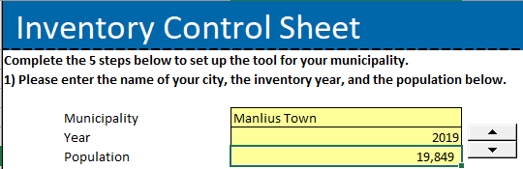

Fig. 1. Setting up Inventory Control Sheet

Step 2- We divided the available data into three sectors to quantify the emissions associated with each sector individually. These sectors are as follows:
- Buildings and facilities – the electricity and natural gas consumption from buildings and facilities provided in these buildings in the town of Manlius are accounted for.
- Streetlights – the electricity consumption from the streetlights is accounted for.
- Vehicle fleet – the emissions associated with vehicles using gasoline, diesel, and kerosene fuel are accounted separately for each of these fuels.
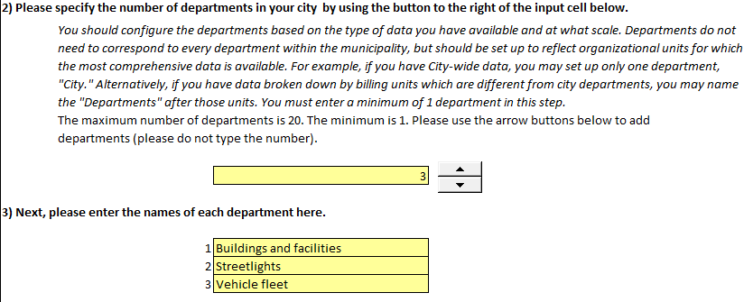
The EPA tool uses the word department instead of the sector; therefore, we referred to these sectors as departments in the control sheet. This step is depicted in the figure below:
Fig. 2. Assigning Sectors in EPA Tool
Step 3 – We established the Emissions and Generation Resource Integrated Database (eGRID) subregion. eGRID is a comprehensive source of data on the environmental characteristics of almost all electric power generated in the United States. The subregion for the town of Manlius is Upstate New York identified as NYUP in the eGRID section of the EPA tool. When we enter this information, we get the following data:
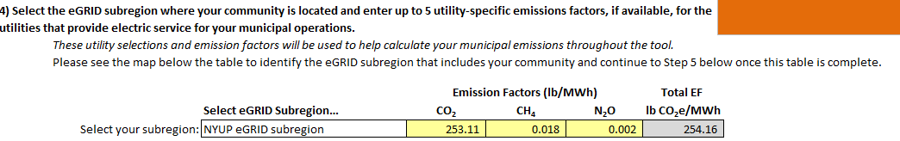
Fig. 3. Setting up eGRID subregion
We observe from this table that for every MWh electricity being consumed in the town of Manlius; 253.11 lb. CO₂, 0.018 lb. CH₄, and 0.002 lb. N₂O is being emitted. GHG gases are CO₂, CH₄ and N₂O but for the sake of simplicity, GHG emissions are scaled as CO₂ equivalent i.e., CO₂e. Therefore, the total emissions factor for the town of Manlius is 254.16 lb. CO₂e/MWh which shows that the one-megawatt electricity which is consumed in Manlius town emits 254.16 lb. of greenhouse gases. This step almost finalizes the Inventory Control Sheet setup and now we can use the data to calculate GHG emissions for the three sectors we described.
Step 4 – There are many tabs in the EPA tool to calculate GHG emissions for different types of sources, for this project we used the following tabs:
- Stationary Entry Tab – We entered natural gas consumption in this tab from the buildings and facilities sector. The data is provided in therms (one therm is equal to 100,000 BTUs) and we converted therms to mcf (1000 cubic feet i.e., 1MMBTU) because the EPA tool needs input in mcf units.
- Stationary Calcs Tab – It gave us an overview of emissions from natural gas for buildings and facilities.
- Electricity Entry Tab – We entered data of electricity consumption for buildings & facilities, and streetlights for two separate sectors (departments) by using this tab.
- Electricity Location-Based Calcs Tab – It gave us the emissions data for buildings & facilities, and streetlights in two separate departments (sectors).
- Mobile Entry Tab – We entered data for the vehicles fleet sector in this tab by identifying vehicles that are using gasoline and diesel as fuel separately. The provided fuel use and vehicle fuel efficiencies in miles per gallons were converted into vehicles miles travelled (VMT) as the EPA tool needs data in VMT. There is not a kerosene option in the mobile entry tab, so we had to work on this calculation separately and add it later to the vehicle fleet sector.
- Mobile Data Tab & Mobile Detail Calcs Tab – These tabs provided emissions data for the vehicle fleet sector.
- Summary Emissions Tab – It was helpful to review the emissions data for the report, although since we added kerosene emissions separately, we would need to create our charts and graphs for the report.

Excluded Data
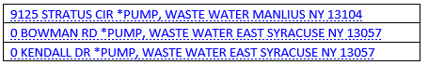
All pump stations have been turned over to Onondaga County as part of the sewer consolidation so the following accounts were not included in this study.

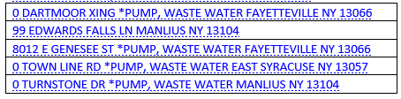

Fig. 4. List of excluded data
We obtained the emissions data for each of the three sectors i.e., buildings & facilities, streetlights, and vehicle fleet by following the above-mentioned steps in the EPA tool. We summarized those results in this final report and presented the findings at the town of Manlius Zoom Board Meeting on the evening of 28th April 2021. We will also recommend ways to reduce GHG emissions and help Manlius town in becoming a Certified Climate Smart Community as per the guidelines of the CSC Certification program and paving the path of New York State towards achieving the goal of becoming a carbon-neutral state.

Emissions Sectors

Vehicle Fleet
There are three types of fossil fuels which are being used in the vehicles of Manlius town and these fuels are gasoline, kerosene, and diesel. Kerosene is mixed into diesel fuels during winter months in a 70/30 ratio to prevent the diesel from gelling. The annual gallons consumption of these fossil fuels was provided by Town of Manlius. This data was used to calculate average miles per gallon for gasoline and diesel fuel. Annual gallons consumed were multiplied with average miles per gallons to obtain vehicle miles travelled (VMT) for gasoline and diesel since EPA tool needs this information in VMT. For kerosene, annual gallons consumed was multiplied with emissions factor of 10.15 kg CO₂/gallons that was provided by ICLEI protocol and converted into metric tons. The details of data along with their associated greenhouse gas emissions are provided in Table 1 and Fig. 5 below:
Name | Gallons Consumed | Miles per gallon | Emissions Factor for Kerosene (kg CO₂/gallon) | Vehicle Miles Travelled | Greenhouse Gas Emissions (MTCO₂e)
Gasoline | 35645 | 20.3 | - | 723,593 | 313
Diesel | 38000 | 11.3 | - | 429,400 | 388
Kerosene | 6643 | - | 10.15 | - | 69.75
Total Emissions | - | - | - | - | 770.75

Table 1. Vehicle Fleet Sector Data

Fig. 5. Vehicle Fleet Emissions

As observed in Table 1 and Fig. 5, total GHG emissions from vehicle fleet sector are 770.75 MTCO₂e and emissions from each fuel i.e., kerosene, gasoline, diesel are 69.75 MTCO₂e, 313 MTCO₂e, 388 MTCO₂e, respectively. The interesting aspect to notice is that emissions from diesel are 50% of the total emissions in vehicle fleet sector.

Streetlights
To have calculated the total emissions from all the streetlights, we had to look at each month separately. Every streetlight account had their total consumption of kWh for each month, so a summation of each month’s total kWh was taken. It was found that the total annual consumption of electricity for streetlight accounts in 2019 was 160,390 kWh. The months of January, February, and March had the highest consumption of energy, as the sun sets earlier in winter months and streetlights therefore run longer.

The annual kWh consumption was then entered into the EPA Calculator with total emissions for the Town of Manlius streetlight accounts in 2019 at 18.49 MTCO₂e. The Town has already converted all cobra head streetlights to LEDs and is in the process of considering conversion of decorative streetlights to LEDs. Another recommendation would be to add solar charged light bulbs for the streetlights. Eventually if all streetlights had this appliance, it would eliminate the town’s dependency on electrical units to power the streetlights constantly; the power grid could be used as a backup power source in the case of reduced sunlight exposure. In turn, GHG emissions would practically be eliminated unless the case of using the electrical grid.

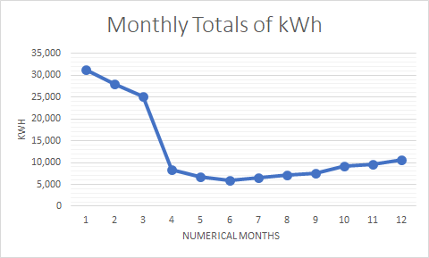

Fig. 6. Streetlights Emissions

Buildings & Facilities
Emissions from buildings and facilities in Manlius come from stationary combustion (heating acquired from natural gas) and electricity use. Emissions were calculated using the EPA tool, and with National Grid bills provided by the Town of Manlius. The total emissions from each area of emissions are outlined in the figure below.

Fig. 7. Buildings and Facilities Emissions

Stationary combustion through natural gas use is the largest source of emissions in the buildings & facilities sector, with 73% of emissions, or 90.53 MTCO₂e being emitted from this process. The heating uses of the buildings and facilities amounted to a total of 17,069 Therms. Electricity use by this sector falls behind natural gas use with 27% of total emissions, or 34.32 MTCO₂e. Electricity usage for this sector amounted to 297,676 kWh. The buildings & facilities sector is responsible for 124.85 MTCO₂e of the total emissions of the Town of Manlius.

Discussion and Summary of Findings
Overall, the three sectors given have provided vastly different emission numbers yet properly represent the municipality. Beginning with streetlights, this sector emitted a total of 18.49 MTCO₂e over the course of the year. In total, this represents 2% of all emissions released from Manlius. Following streetlights, the buildings & facilities had total emissions of 124.85 MTCO₂e, or 14% of total emissions. Finally, the vehicle fleet sector was by far the largest emitting sector, producing 770.75 MTCO₂e, or 84% of all emissions. Total emissions for 2019 for the Town of Manlius municipal operations was 914.09 MTCO₂e.

Figure 8: Total emissions from all three sectors

Recommendations
The emissions from vehicle fleet sector can be reduced in the following ways:
- Electric vehicles are electric vehicles are much cleaner to operate than other types of vehicles, especially in upstate NY where the electric grid is made up of primarily low emitting sources, such as hydropower and nuclear power. In the future, as the electric grid make up becomes more comprised of renewable fuels, electric vehicles will run even cleaner. Because of that, electric vehicles could be considered for future fleet replacements at the Town. While electric heavy-duty vehicles are currently more difficult and expensive to come by, new options are increasingly becoming available that the Town can consider in the future.
- According to Alternate Fuels Data Center of the US Department of Energy:
          - Natural gas vehicles are another option that could be used to reduce GHG emissions by about 11% when compared with diesel vehicles.
          - Biofuels are another alternative fuel which can be used to reduce GHG emissions. Biodiesel 20 (B20) blend can be used in any vehicle without engine modification which was manufactured either in 2001 or after that and B20 can reduce GHG emissions by 20% when compared with conventional diesel vehicles.
          - Ethanol 85 (E85) blend can reduce emissions by 34% compared to diesel vehicles, but E85 blend cannot be used in conventional vehicles without engine modification since this fuel can only be used in flexible fuel vehicles.
          - An important thing to note is that these fuels (natural gas, biodiesel, ethanol) can only be utilized successfully if there is an appropriate fill station available for the Town's use. These can be costly to install if needed.
- Emissions from buildings and facilities can be reduced in the following ways:
- Contracting energy audits of buildings to ascertain energy saving areas.
- Invest in modern insulation, increasing efficiency in heating.
- Invest in modern, energy efficient windows to increase heating and cooling efficiency.
These and other emissions reduction strategies can be discussed further in a municipal operations Climate Action Plan.

Conclusion
We found that total emissions of Manlius Town for 2019 year from three sectors studied in this project are 914.09 MTCO₂e and emissions from each sector buildings and facilities, streetlights, vehicle fleet are 124.85 MTCO₂e, 18.49 MTCO₂e, 770.75 MTCO₂e, respectively. Vehicle fleet, buildings and facilities, streetlights contribute 84%, 14%, 2%, respectively to total emissions of Manlius Town for 2019 year. The use of electric vehicles, natural gas vehicles, and/or biofuels could reduce GHG emissions from vehicle fleet. The use of energy efficient windows, upgrading insulation, and periodic energy audits could reduce GHG emissions from buildings and facilities. The emissions from streetlights are very low because streetlights are already upgraded, but proper maintenance of these streetlights is needed to keep emissions low.

References

The Fifth Assessment Report of Intergovernmental Panel on Climate Change, 2014. Retrieved from: https://www.ipcc.ch/site/assets/uploads/2018/02/SYR_AR5_FINAL_full.pdf
Pathways to Deep Decarbonization in New York State report, 2020. Retrieved from: https://climate.ny.gov/-/media/CLCPA/Files/2020-06-24-NYS-Decarbonization-Pathways-Report.pdf
ICLEI Local Governments Operation Protocol. Retrieved from: https://villedurabledotorg.files.wordpress.com/2012/12/iclei_us_community_protocol_v1_oct_2012.pdf
United States EPA Inventory Tool. Retrieved from: https://www.epa.gov/statelocalenergy/local-greenhouse-gas-inventory-tool
Climate Smart Community Certification Program. Retrieved from: https://climatesmart.ny.gov/
Climate Change effects on New York State. Retrieved from: https://www.dec.ny.gov/energy/94702
Alternate Fuels Data Center of US Department of Energy. Retrieved from: https://afdc.energy.gov/

